Ex.No:1 Implementation of Tic-Toe-Game
Aim: To Implement of Two Player Tic-Tac-Toe game in Python.
Algorithm:
● play_game() is the main function, which performs the following tasks:
● Calls create_board() to create a 3x3 board and initializes with 0.
● Get input from the player whose turn it is and check whether the place is marked or not.
● If it is marked, display "error" else mark the location.
● Print the board after each move.
● Evaluate the board with each move to check whether a row or column or a diagonal has the same X or O.
● If so, display the winner name. If number of moves is greater than or equal to 8, there are no winners. Display "draw" then.
SOURCE CODE:

#Implementation of Two Player Tic-Tac-Toe game in Python.

''' We will make the board using dictionary in which keys will be the location(i.e : top-left,mid-right,etc.)and initialliy it's values will be empty space and then after every move we will change the value according to player's choice of move. '''

theBoard = {'7': ' ' , '8': ' ' , '9': ' ' ,
'4': ' ' , '5': ' ' , '6': ' ' ,
'1': ' ' , '2': ' ' , '3': ' ' }

board_keys = []

for key in theBoard:
board_keys.append(key)

''' We will have to print the updated board after every move in the game and thus we will make a function in which we'll define the printBoard function so that we can easily print the board everytime by calling this function. '''

def printBoard(board):
print(board['7'] + '|' + board['8'] + '|' + board['9'])
print('-+-+-')
print(board['4'] + '|' + board['5'] + '|' + board['6'])
print('-+-+-')
print(board['1'] + '|' + board['2'] + '|' + board['3'])

# Now we'll write the main function which has all the gameplay functionality.
def game():

turn = 'X'
count = 0

for i in range(10):
printBoard(theBoard)
print("It's your turn," + turn + ".Move to which place?")

move = input()

if theBoard[move] == ' ':
theBoard[move] = turn
count += 1
else:
print("That place is already filled.\nMove to which place?")
continue

# Now we will check if player X or O has won,for every move after 5 moves.
if count >= 5:
if theBoard['7'] == theBoard['8'] == theBoard['9'] != ' ': # across the top
printBoard(theBoard)
print("\nGame Over.\n")
print(" **** " +turn + " won. ****")
break
elif theBoard['4'] == theBoard['5'] == theBoard['6'] != ' ': # across the middle
printBoard(theBoard)
print("\nGame Over.\n")
print(" **** " +turn + " won. ****")
break
elif theBoard['1'] == theBoard['2'] == theBoard['3'] != ' ': # across the bottom
printBoard(theBoard)
print("\nGame Over.\n")
print(" **** " +turn + " won. ****")
break
elif theBoard['1'] == theBoard['4'] == theBoard['7'] != ' ': # down the left side
printBoard(theBoard)
print("\nGame Over.\n")
print(" **** " +turn + " won. ****")
break
elif theBoard['2'] == theBoard['5'] == theBoard['8'] != ' ': # down the middle
printBoard(theBoard)
print("\nGame Over.\n")
print(" **** " +turn + " won. ****")
break
elif theBoard['3'] == theBoard['6'] == theBoard['9'] != ' ': # down the right side
printBoard(theBoard)
print("\nGame Over.\n")
print(" **** " +turn + " won. ****")
break
elif theBoard['7'] == theBoard['5'] == theBoard['3'] != ' ': # diagonal
printBoard(theBoard)
print("\nGame Over.\n")
print(" **** " +turn + " won. ****")
break
elif theBoard['1'] == theBoard['5'] == theBoard['9'] != ' ': # diagonal
printBoard(theBoard)
print("\nGame Over.\n")
print(" **** " +turn + " won. ****")
break

# If neither X nor O wins and the board is full, we'll declare the result as 'tie'.
if count == 9:
print("\nGame Over.\n")
print("It's a Tie!!")

# Now we have to change the player after every move.
if turn =='X':
turn = 'O'
else:
turn = 'X'

# Now we will ask if player wants to restart the game or not.
restart = input("Do want to play Again?(y/n)")
if restart == "y" or restart == "Y":
for key in board_keys:
theBoard[key] = " "

game()

if __name__ == "__main__":
game()
OUTPUT:
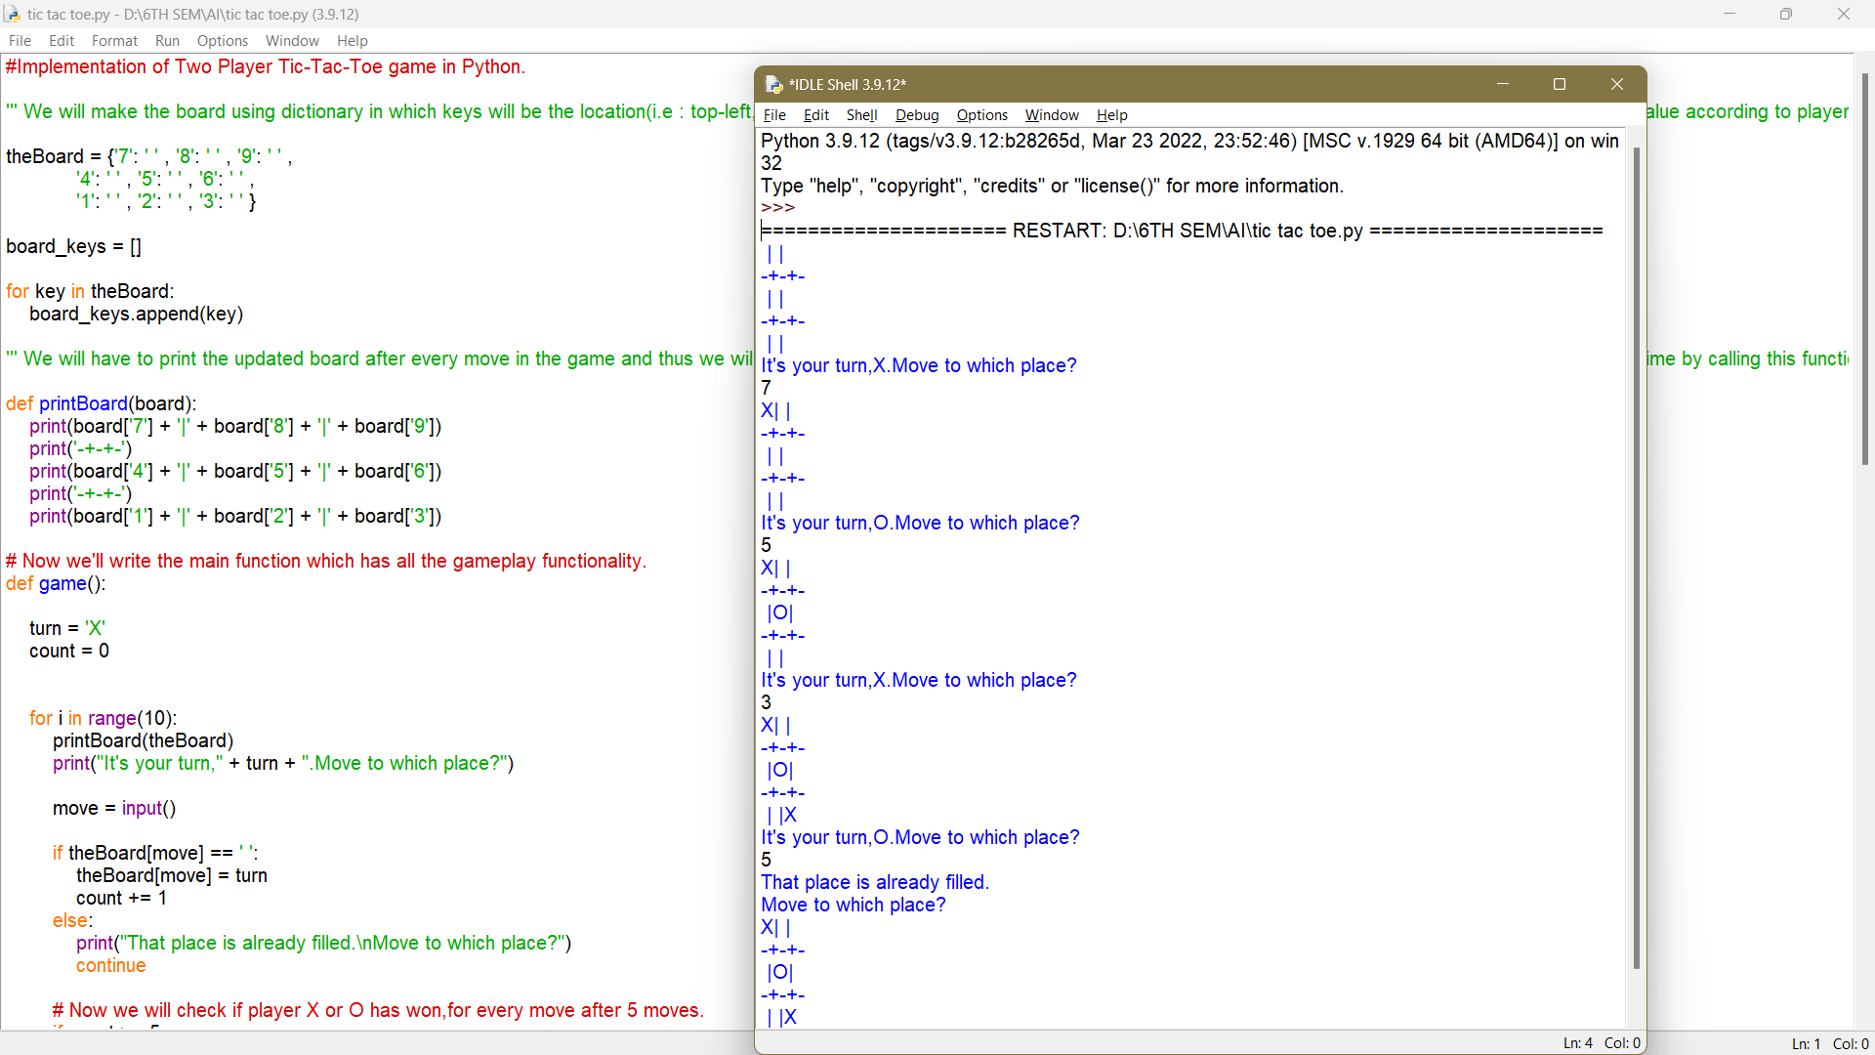

EXP:2 Developing agent programs for real world problems (8-puzzle)
Aim:
To develop agent programs for real world problems like 8-puzzle.
Algorithm:
1. The program is started.
2. We imported random and math modules.
3. Final state is created.
4. Eight puzzle matrix is created.
5. Solve function is used to solve the matrix we want to find.
6. Here function is used to provide current and target position for each number.
7. Required matrix is printed in each step.
8. The program is closed.
SOURCE CODE:

# Importing copy for deepcopy function
import copy

# Importing the heap functions from python
# library for Priority Queue
from heapq import heappush, heappop

# This variable can be changed to change
# the program from 8 puzzle(n=3) to 15
# puzzle(n=4) to 24 puzzle(n=5)...
n = 3

# bottom, left, top, right
row = [ 1, 0, -1, 0 ]
col = [ 0, -1, 0, 1 ]

# A class for Priority Queue
class priorityQueue:

# Constructor to initialize a
# Priority Queue
def __init__(self):
self.heap = []

# Inserts a new key 'k'
def push(self, k):
heappush(self.heap, k)

# Method to remove minimum element
# from Priority Queue
def pop(self):
return heappop(self.heap)

# Method to know if the Queue is empty
def empty(self):
if not self.heap:
return True
else:
return False

# Node structure
class node:

def __init__(self, parent, mat, empty_tile_pos,
cost, level):

# Stores the parent node of the
# current node helps in tracing
# path when the answer is found
self.parent = parent

# Stores the matrix
self.mat = mat

# Stores the position at which the
# empty space tile exists in the matrix
self.empty_tile_pos = empty_tile_pos

# Storesthe number of misplaced tiles
self.cost = cost

# Stores the number of moves so far
self.level = level

# This method is defined so that the
# priority queue is formed based on
# the cost variable of the objects
def __lt__(self, nxt):
return self.cost < nxt.cost

# Function to calculate the number of
# misplaced tiles ie. number of non-blank
# tiles not in their goal position
def calculateCost(mat, final) -> int:

count = 0
for i in range(n):
for j in range(n):
if ((mat[i][j]) and
(mat[i][j] != final[i][j])):
count += 1

return count

def newNode(mat, empty_tile_pos, new_empty_tile_pos,
level, parent, final) -> node:

# Copy data from parent matrix to current matrix
new_mat = copy.deepcopy(mat)

# Move tile by 1 position
x1 = empty_tile_pos[0]
y1 = empty_tile_pos[1]
x2 = new_empty_tile_pos[0]
y2 = new_empty_tile_pos[1]
new_mat[x1][y1], new_mat[x2][y2] = new_mat[x2][y2], new_mat[x1][y1]

# Set number of misplaced tiles
cost = calculateCost(new_mat, final)

new_node = node(parent, new_mat, new_empty_tile_pos,
cost, level)
return new_node

# Function to print the N x N matrix
def printMatrix(mat):

for i in range(n):
for j in range(n):
print("%d " % (mat[i][j]), end = " ")

print()

# Function to check if (x, y) is a valid
# matrix coordinate
def isSafe(x, y):

return x >= 0 and x < n and y >= 0 and y < n

# Print path from root node to destination node
def printPath(root):

if root == None:
return

printPath(root.parent)
printMatrix(root.mat)
print()

# Function to solve N*N - 1 puzzle algorithm
# using Branch and Bound. empty_tile_pos is
# the blank tile position in the initial state.
def solve(initial, empty_tile_pos, final):

# Create a priority queue to store live
# nodes of search tree
pq = priorityQueue()

# Create the root node
cost = calculateCost(initial, final)
root = node(None, initial,
empty_tile_pos, cost, 0)

# Add root to list of live nodes
pq.push(root)

# Finds a live node with least cost,
# add its children to list of live
# nodes and finally deletes it from
# the list.
while not pq.empty():

# Find a live node with least estimated
# cost and delete it form the list of
# live nodes
minimum = pq.pop()

# If minimum is the answer node
if minimum.cost == 0:

# Print the path from root to
# destination;
printPath(minimum)
return

# Generate all possible children
for i in range(n):
new_tile_pos = [
minimum.empty_tile_pos[0] + row[i],
minimum.empty_tile_pos[1] + col[i], ]

if isSafe(new_tile_pos[0], new_tile_pos[1]):

# Create a child node
child = newNode(minimum.mat,
minimum.empty_tile_pos,
new_tile_pos,
minimum.level + 1,
minimum, final,)

# Add child to list of live nodes
pq.push(child)

# Driver Code

# Initial configuration
# Value 0 is used for empty space
initial = [ [ 1, 2, 3 ],
[ 5, 6, 0 ],
[ 7, 8, 4 ] ]

# Solvable Final configuration
# Value 0 is used for empty space
final = [ [ 1, 2, 3 ],
[ 5, 8, 6 ],
[ 0, 7, 4 ] ]

# Blank tile coordinates in
# initial configuration
empty_tile_pos = [ 1, 2 ]

# Function call to solve the puzzle
solve(initial, empty_tile_pos, final)

OUTPUT:
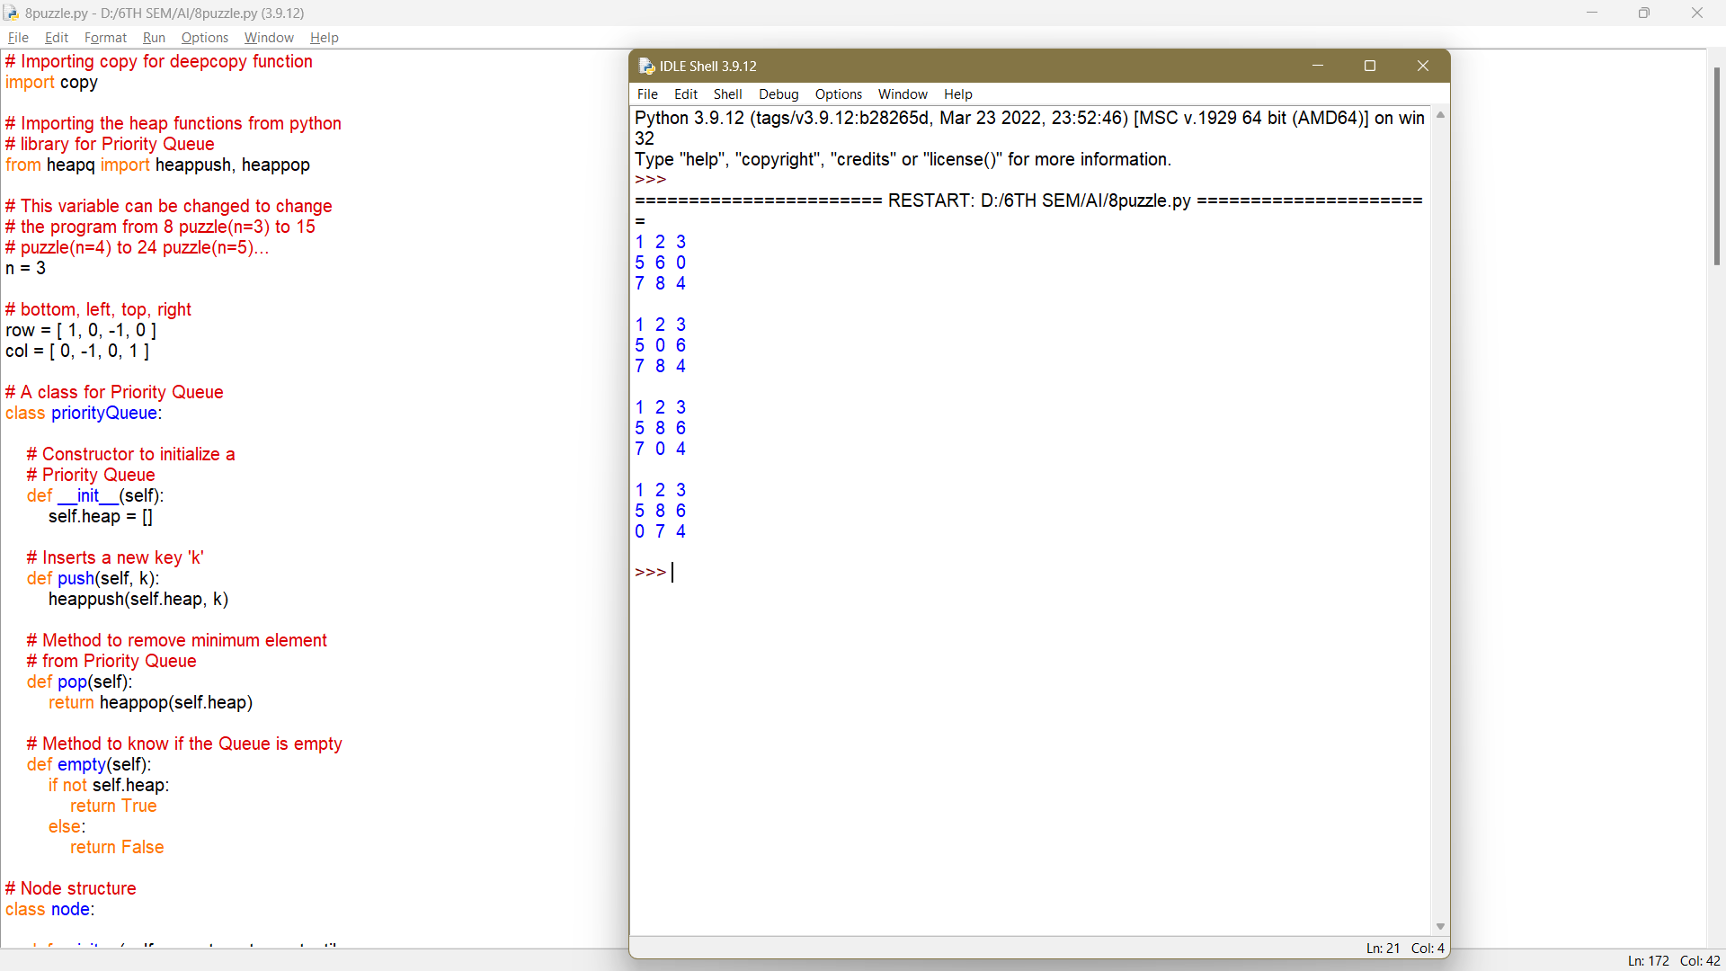

EX 3 Implementation of constraint satisfaction problems (Cryptarithmetic Problem)
AIM:
To Implement a constraint satisfaction problem (Cryptarithmetic Problem).
ALGORITHM:
1.Start program
2.Get input from the user
3.input is run through the functions
4.each input is calculated with a corresponding for loop
5.if the sum of the first two numbers is equal to third, return true. Else return False.
6.Then, it is put through a recursive function to check solution for all permutations
7.The result should satisfy the predefined arithmetic rules
8.Result is printed
9.End program

SOURCE CODE:

// CPP program for solving cryptographic puzzles
#include <bits/stdc++.h>
using namespace std;

// vector stores 1 corresponding to index
// number which is already assigned
// to any char, otherwise stores 0
vector<int> use(10);

// structure to store char and its corresponding integer
struct node
{
char c;
int v;
};

// function check for correct solution
int check(node* nodeArr, const int count, string s1,
string s2, string s3)
{
int val1 = 0, val2 = 0, val3 = 0, m = 1, j, i;

// calculate number corresponding to first string
for (i = s1.length() - 1; i >= 0; i--)
{
char ch = s1[i];
for (j = 0; j < count; j++)
if (nodeArr[j].c == ch)
break;

val1 += m * nodeArr[j].v;
m *= 10;
}
m = 1;

// calculate number corresponding to second string
for (i = s2.length() - 1; i >= 0; i--)
{
char ch = s2[i];
for (j = 0; j < count; j++)
if (nodeArr[j].c == ch)
break;

val2 += m * nodeArr[j].v;
m *= 10;
}
m = 1;

// calculate number corresponding to third string
for (i = s3.length() - 1; i >= 0; i--)
{
char ch = s3[i];
for (j = 0; j < count; j++)
if (nodeArr[j].c == ch)
break;

val3 += m * nodeArr[j].v;
m *= 10;
}

// sum of first two number equal to third return true
if (val3 == (val1 + val2))
return 1;

// else return false
return 0;
}

// Recursive function to check solution for all permutations
bool permutation(const int count, node* nodeArr, int n,
string s1, string s2, string s3)
{
// Base case
if (n == count - 1)
{

// check for all numbers not used yet
for (int i = 0; i < 10; i++)
{

// if not used
if (use[i] == 0)
{

// assign char at index n integer i
nodeArr[n].v = i;

// if solution found
if (check(nodeArr, count, s1, s2, s3) == 1)
{
cout << "\nSolution found: ";
for (int j = 0; j < count; j++)
cout << " " << nodeArr[j].c << " = "
<< nodeArr[j].v;
return true;
}
}
}
return false;
}

for (int i = 0; i < 10; i++)
{

// if ith integer not used yet
if (use[i] == 0)
{

// assign char at index n integer i
nodeArr[n].v = i;

// mark it as not available for other char
use[i] = 1;

// call recursive function
if (permutation(count, nodeArr, n + 1, s1, s2, s3))
return true;

// backtrack for all other possible solutions
use[i] = 0;
}
}
return false;
}

bool solveCryptographic(string s1, string s2,
string s3)
{
// count to store number of unique char
int count = 0;

// Length of all three strings
int l1 = s1.length();
int l2 = s2.length();
int l3 = s3.length();

// vector to store frequency of each char
vector<int> freq(26);

for (int i = 0; i < l1; i++)
++freq[s1[i] - 'A'];

for (int i = 0; i < l2; i++)
++freq[s2[i] - 'A'];

for (int i = 0; i < l3; i++)
++freq[s3[i] - 'A'];

// count number of unique char
for (int i = 0; i < 26; i++)
if (freq[i] > 0)
count++;

// solution not possible for count greater than 10
if (count > 10)
{
cout << "Invalid strings";
return 0;
}

// array of nodes
node nodeArr[count];

// store all unique char in nodeArr
for (int i = 0, j = 0; i < 26; i++)
{
if (freq[i] > 0)
{
nodeArr[j].c = char(i + 'A');
j++;
}
}
return permutation(count, nodeArr, 0, s1, s2, s3);
}

// Driver function
int main()
{
string s1 = "SEND";
string s2 = "MORE";
string s3 = "MONEY";

if (solveCryptographic(s1, s2, s3) == false)
cout << "No solution";
return 0;
}

OUTPUT:
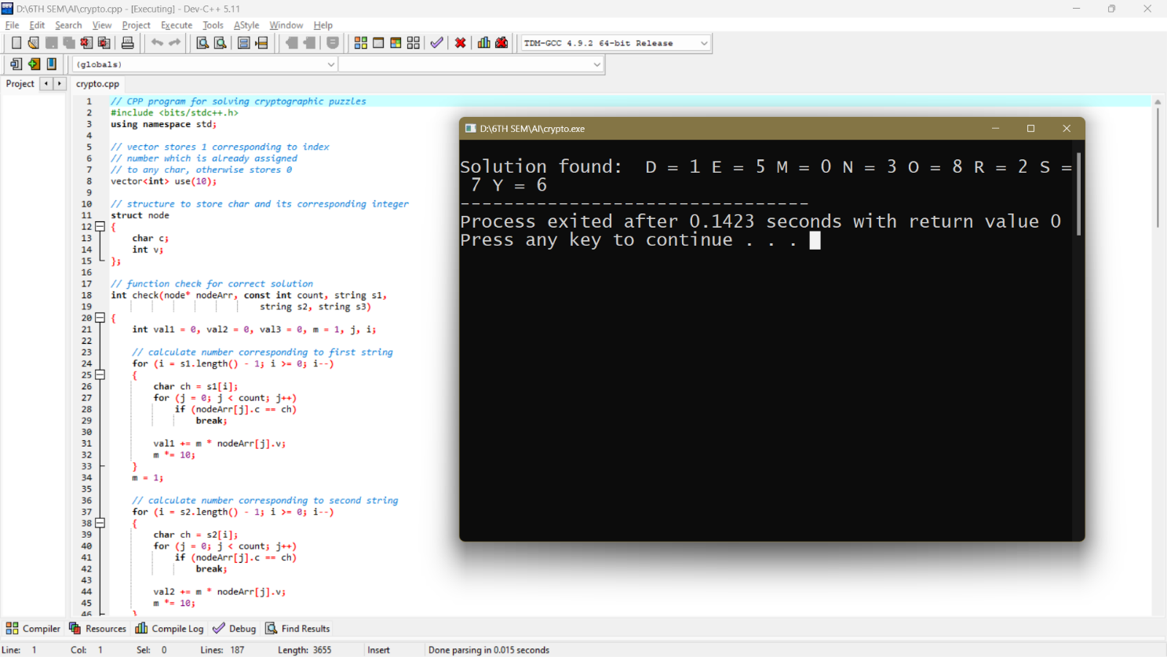

EXP.NO:4 Implementation and Analysis of DFS and BFS for an application
AIM:
To implement and analysis of DFS and BFS for an Application.

ALGORITHM:
#DFS Algorithm:
• Start by putting any one of the graph's vertices on top of the stack.
• After that take the top item of the stack and add it to the visited list of the vertex.
• Next, create a list of that adjacent node of the vertex. Add the ones which aren't in
the visited list of vertexes to the top of the stack.
• Lastly, keep repeating steps 2 and 3 until the stack is empty.
• Stop

# BFS ALGORITHM:
• Start by putting any one of the graph’s vertices at the back of the queue.
• Now take the front item of the queue and add it to the visited list.
• Create a list of that vertex's adjacent nodes. Add those which are not within the

visited list to the rear of the queue.

• Keep continuing steps two and three till the queue is empty.
• Stop

SOURCE CODE:

# DFS algorithm in Python
# DFS algorithm
def dfs(graph, start, visited=None):
if visited is None:
visited = set()
visited.add(start)
print(start)
for next in graph[start] - visited:
dfs(graph, next, visited)
return visited
graph = {'0': set(['1', '2']),
'1': set(['0', '3', '4']),
'2': set(['0']),
'3': set(['1']),
'4': set(['2', '3'])}
dfs(graph, '0')
OUTPUT:
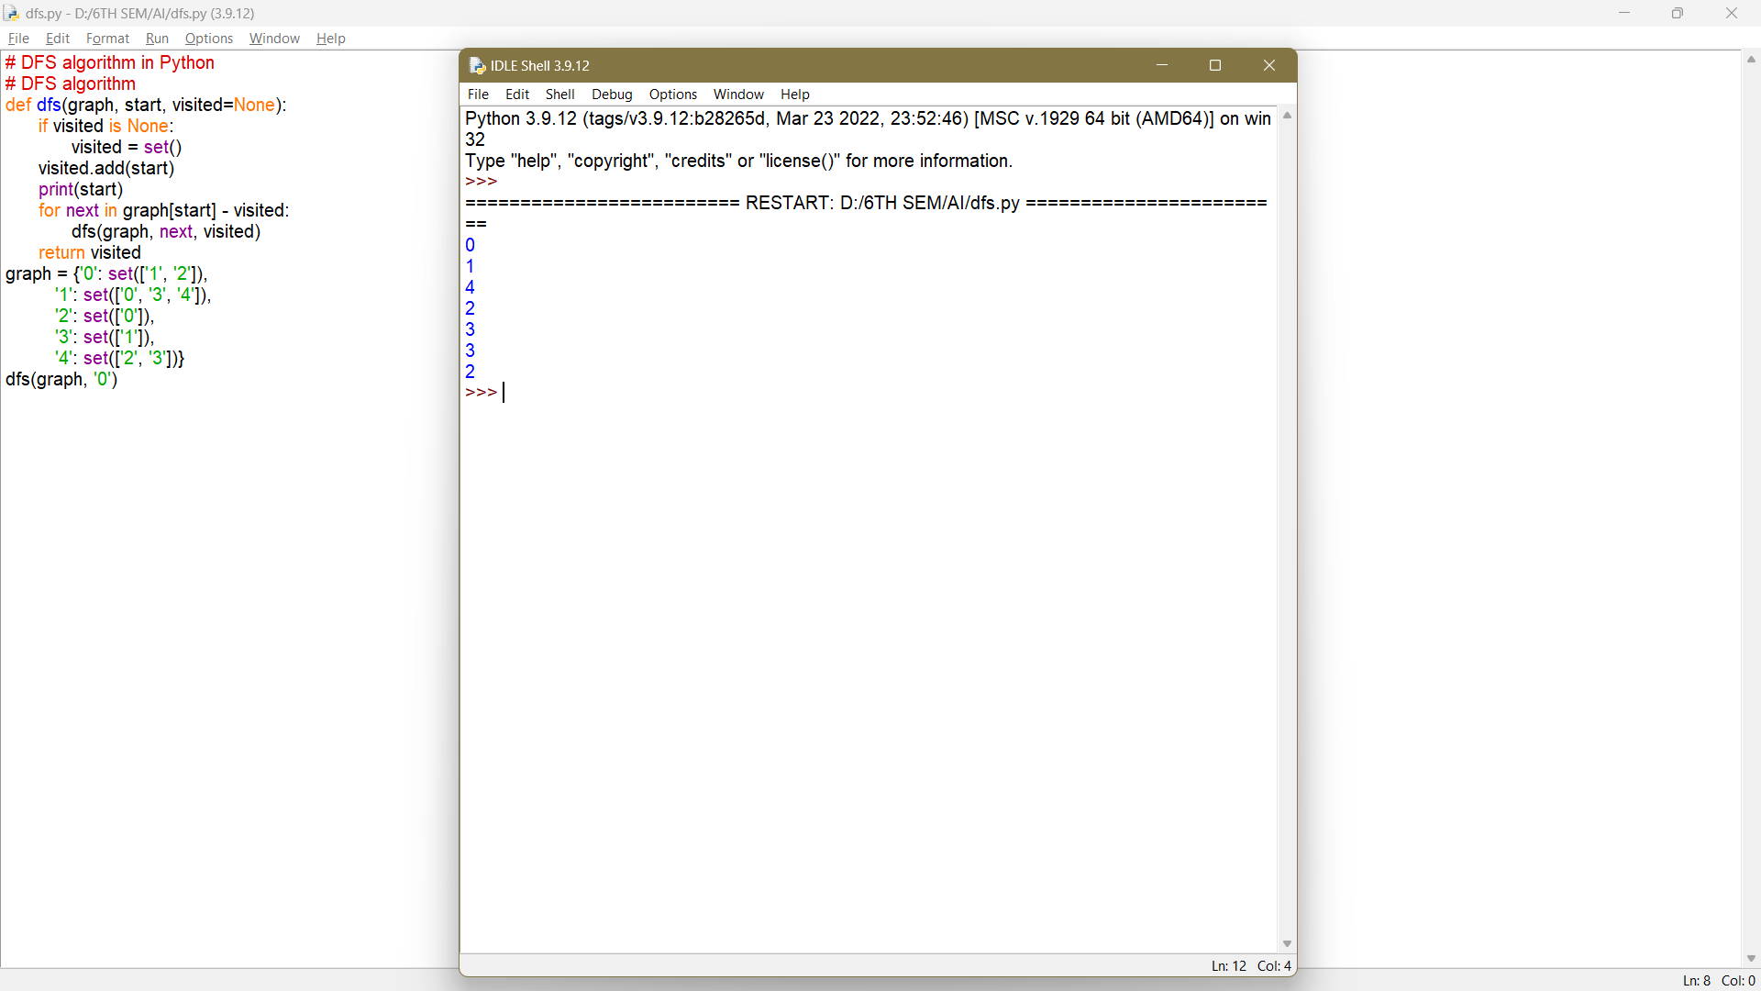
SOURCE CODE:

# BFS algorithm in Python
import collections
# BFS algorithm
def bfs(graph, root):
visited, queue = set(), collections.deque([root])
visited.add(root)
while queue:
# Dequeue a vertex from queue
vertex = queue.popleft()
print(str(vertex) + " ", end="")
# If not visited, mark it as visited, and
# enqueue it
for neighbour in graph[vertex]:
if neighbour not in visited:
visited.add(neighbour)
queue.append(neighbour)
if __name__ == '__main__':
graph = {0: [1, 2], 1: [2], 2: [3], 3: [1, 2]}
print("Following is Breadth First Traversal: ")
bfs(graph, 0)
OUTPUT:
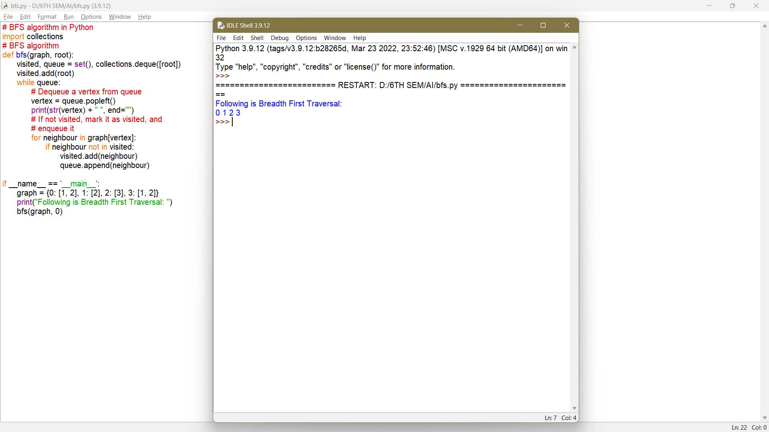

EX 5: Best first search and A* Algorithm
AIM:
To Develop Best first search and A* Algorithm for real world problems
ALGORITHM:
1. Create 2 empty lists: OPEN and CLOSED
2. Start from the initial node (say N) and put it in the ‘ordered’ OPEN list
3. Repeat the next steps until GOAL node is reached
4. If OPEN list is empty, then EXIT the loop returning ‘False’
5. Select the first/top node (say N) in the OPEN list and move it to the
CLOSED list. Also capture the information of the parent node
6. If N is a GOAL node, then move the node to the Closed list and exit the
loop returning ‘True’. The solution can be found by backtracking the path
7. If N is not the GOAL node, expand node N to generate the ‘immediate’
next nodes linked to node N and add all those to the OPEN list
8. Reorder the nodes in the OPEN list in ascending order according to an
evaluation function f(n)
SOURCE CODE:
class Node():
"""A node class for A* Pathfinding"""
def __init__(self, parent=None, position=None):
self.parent = parent
self.position = position
self.g = 0
self.h = 0
self.f = 0
def __eq__(self, other):
return self.position == other.position
def astar(maze, start, end):
"""Returns a list of tuples as a path from the given start to the given end in the given maze"""
# Create start and end node
start_node = Node(None, start)
start_node.g = start_node.h = start_node.f = 0
end_node = Node(None, end)
nd_node.g = end_node.h = end_node.f = 0
# Initialize both open and closed list
open_list = []
closed_list = []
# Add the start node
open_list.append(start_node)
# Loop until you find the end
while len(open_list) > 0:
# Get the current node
current_node = open_list[0]
current_index = 0
for index, item in enumerate(open_list):
if item.f < current_node.f:
current_node = item
current_index = index
# Pop current off open list, add to closed list
open_list.pop(current_index)
closed_list.append(current_node)
# Found the goal
if current_node == end_node:
path = []
current = current_node
while current is not None:
path.append(current.position)
current = current.parent
return path[::-1] # Return reversed path
# Generate children
children = []
for new_position in [(0, -1), (0, 1), (-1, 0), (1, 0), (-1, -1), (-1, 1), (1,-1), (1, 1)]: # Adjacent squares
# Get node position
node_position = (current_node.position[0] + new_position[0],current_node.position[1] + new_position[1])
# Make sure within range
if node_position[0] > (len(maze) - 1) or node_position[0] < 0 or node_position[1] > (len(maze[len(maze)-1]) -1) or node_position[1] < 0:
continue
# Make sure walkable terrain
if maze[node_position[0]][node_position[1]] != 0:
continue
# Create new node
new_node = Node(current_node, node_position)
# Append
children.append(new_node)
# Loop through children
for child in children:
# Child is on the closed list
for closed_child in closed_list:
if child == closed_child:
continue
# Create the f, g, and h values
child.g = current_node.g + 1
child.h = ((child.position[0] - end_node.position[0]) ** 2) + ((child.position[1] - end_node.position[1]) ** 2)
child.f = child.g + child.h
# Child is already in the open list
for open_node in open_list:
if child == open_node and child.g > open_node.g:
continue
# Add the child to the open list
open_list.append(child)
def main():
maze = [[0, 0, 0, 0, 1, 0, 0, 0, 0, 0],
[0, 0, 0, 0, 1, 0, 0, 0, 0, 0],
[0, 0, 0, 0, 1, 0, 0, 0, 0, 0],
[0, 0, 0, 0, 1, 0, 0, 0, 0, 0],
[0, 0, 0, 0, 1, 0, 0, 0, 0, 0],
[0, 0, 0, 0, 0, 0, 0, 0, 0, 0],
[0, 0, 0, 0, 1, 0, 0, 0, 0, 0],
[0, 0, 0, 0, 1, 0, 0, 0, 0, 0],
[0, 0, 0, 0, 1, 0, 0, 0, 0, 0],
[0, 0, 0, 0, 0, 0, 0, 0, 0, 0]]
start = (0, 0)
end = (7, 6)
path = astar(maze, start, end)
print(path)
if __name__ == '__main__':
main()
OUTPUT:
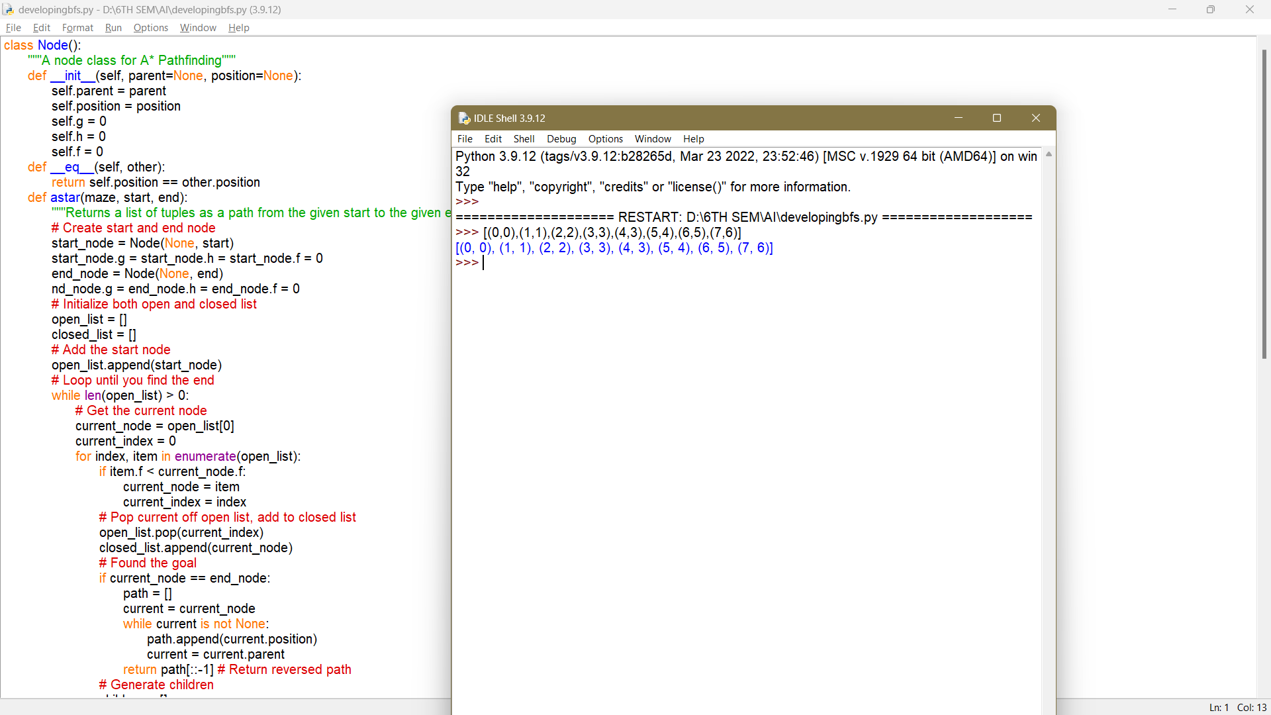
EX 6: MIN-MAX
Aim: To implement min-max algorithm for an application.
Algorithm:
1. Mini-max algorithm is a recursive or backtracking algorithm which is used in decision-making and game theory. It provides an optimal move for the player assuming that opponent is also playing optimally.
2. Mini-Max algorithm uses recursion to search through the game-tree.
3. Min-Max algorithm is mostly used for game playing in AI. Such as Chess, Checkers, tic-tac-toe, go, and various tow-players game,this Algorithm computes the mini-max decision for the current state.
4. In this algorithm two players play the game, one is called MAX and other is called MIN.
5. Both the players fight it as the opponent player gets the minimum benefit while they get the maximum benefit.
6. Both Players of the game are opponents of each other, where MAX will select the maximized value and MIN will select the minimized value.
7. The mini-max algorithm performs a depth-first search algorithm for the exploration of the complete game tree.
8. The mini-max algorithm proceeds all the way down to the terminal node of the tree, then backtrack the tree as the recursion.
SOURCE CODE:
# Import libraries
import sys
import random
# This class represent a tic tac to game
class TicTacToeGame:
# Create a new game
def __init__(self, rows:int, columns:int, goal:int, max_depth:int=4):

# Create the game state
self.state = []
self.tiles = {}
self.inverted_tiles = {}
tile = 0
for y in range(rows):
row = []
for x in range(columns):
row += '.'
tile += 1
self.tiles[tile] = (y, x)
self.inverted_tiles[(y, x)] = tile
self.state.append(row)
# Set the number of noughts and crosses in a row that is needed to win the game
self.goal = goal
# Create vectors
self.vectors = [(1,0), (0,1), (1,1), (-1,1)]
# Set lengths
self.rows = rows
self.columns = columns
self.max_row_index = rows - 1
self.max_columns_index = columns - 1
self.max_depth = max_depth
# Heuristics for cutoff
self.winning_positions = []
self.get_winning_positions()
# Set the starting player at random
#self.player = 'O'
self.player = random.choice(['X', 'O'])
# Get winning positions
def get_winning_positions(self):
# Loop the board
for y in range(self.rows):
for x in range(self.columns):

# Loop vectors
for vector in self.vectors:

# Get the start position
sy, sx = (y, x)
# Get vector deltas
dy, dx = vector
# Create a counter
counter = 0
# Loop until we are outside the board
positions = []
while True:
# Add the position
positions.append(self.inverted_tiles.get((sy, sx)))
# Check if we have a winning position
if (len(positions) == self.goal):
# Add winning positions
self.winning_positions.append(positions)
# Break out from the loop
break
# Update the position
sy += dy
sx += dx

# Check if the loop should terminate
if(sy < 0 or abs(sy) > self.max_row_index or sx < 0 or abs(sx) > self.max_columns_index):
break
# Play the game
def play(self):
# Variables
result = None
# Create an infinite loop
print('Starting board')
while True:
# Draw the state
self.print_state()
# Get a move from a player
if (self.player == 'X'): # AI
# Print AI move
print('Player X moving (AI) ...')
# Get the best move
max, py, px, depth = self.max(-sys.maxsize, sys.maxsize)
# Get a heuristic move at cutoff
print('Depth: {0}'.format(depth))
if(depth > self.max_depth):
py, px = self.get_best_move()
# Make a move
self.state[py][px] = 'X'
# Check if the game has ended, break out from the loop in that case
result = self.game_ended()
if(result != None):
break
# Change turn
self.player = 'O'
elif (self.player == 'O'): # Human player

# Print turn
print('Player O moving (Human) ...')
# Get a recommended move
min, py, px, depth = self.min(-sys.maxsize, sys.maxsize)
# Get a heuristic move at cutoff
print('Depth: {0}'.format(depth))
if(depth > self.max_depth):
py, px = self.get_best_move()
# Print a recommendation
print('Recommendation: {0}'.format(self.inverted_tiles.get((py, px))))
# Get input
number = int(input('Make a move (tile number): '))
tile = self.tiles.get(number)
# Check if the move is legal
if(tile != None):

# Make a move
py, px = tile
self.state[py][px] = 'O'
# Check if the game has ended, break out from the loop in that case
result = self.game_ended()
if(result != None):
break
# Change turn
self.player = 'X'
else:
print('Move is not legal, try again.')
# Print result
self.print_state()
print('Winner is player: {0}'.format(result))
# An evaluation function to get the best move based on heuristics
def get_best_move(self):
# Create an heuristic dictionary
heuristics = {}
# Get all empty cells
empty_cells = []
for y in range(self.rows):
for x in range(self.columns):
if (self.state[y][x] == '.'):
empty_cells.append((y, x))
# Loop empty positions
for empty in empty_cells:
# Get numbered position
number = self.inverted_tiles.get(empty)
# Loop winning positions
for win in self.winning_positions:
# Check if number is in a winning position
if(number in win):
# Calculate the number of X:s and O:s in the winning position
player_x = 0
player_o = 0
start_score = 1
for box in win:
# Get the position
y, x = self.tiles[box]
# Count X:s and O:s
if(self.state[y][x] == 'X'):
player_x += start_score if self.player == 'X' else start_score * 2
start_score *= 10
elif (self.state[y][x] == 'O'):
player_o += start_score if self.player == 'O' else start_score * 2
start_score *= 10
# Save heuristic
if(player_x == 0 or player_o == 0):
# Calculate a score
score = max(player_x, player_o) + start_score
# Update the score
if(heuristics.get(number) != None):
heuristics[number] += score
else:
heuristics[number] = score
# Get the best move from the heuristic dictionary
best_move = random.choice(empty_cells)
best_count = -sys.maxsize
for key, value in heuristics.items():
if(value > best_count):
best_move = self.tiles.get(key)
best_count = value
# Return the best move
return best_move
# Check if the game has ended
def game_ended(self) -> str:
# Check if a player has won
result = self.player_has_won()
if(result != None):
return result
# Check if the board is full
for y in range(self.rows):
for x in range(self.columns):
if (self.state[y][x] == '.'):
return None
# Return a tie
return 'It is a tie!'

# Check if a player has won
def player_has_won(self) -> str:

# Loop the board
for y in range(self.rows):
for x in range(self.columns):

# Loop vectors
for vector in self.vectors:

# Get the start position
sy, sx = (y, x)
# Get vector deltas
dy, dx = vector
# Create counters
steps = 0
player_x = 0
player_o = 0
# Loop until we are outside the board or have moved the number of steps in the goal
while steps < self.goal:
# Add steps
steps += 1
# Check if a player has a piece in the tile
if(self.state[sy][sx] == 'X'):
player_x += 1
elif(self.state[sy][sx] == 'O'):
player_o += 1
# Update the position
sy += dy
sx += dx

# Check if the loop should terminate
if(sy < 0 or abs(sy) > self.max_row_index or sx < 0 or abs(sx) > self.max_columns_index):
break
# Check if we have a winner
if(player_x >= self.goal):
return 'X'
elif(player_o >= self.goal):
return 'O'
# Return None if no winner is found
return None
# Get a min value (O)
def min(self, alpha:int=-sys.maxsize, beta:int=sys.maxsize, depth:int=0):

# Variables
min_value = sys.maxsize
by = None
bx = None

# Check if the game has ended
result = self.game_ended()
if(result != None):
if result == 'X':
return 1, 0, 0, depth
elif result == 'O':
return -1, 0, 0, depth
elif result == 'It is a tie!':
return 0, 0, 0, depth
elif(depth > self.max_depth):
return 0, 0, 0, depth
# Loop the board
for y in range(self.rows):
for x in range(self.columns):
# Check if the tile is empty
if (self.state[y][x] == '.'):
# Make a move
self.state[y][x] = 'O'
# Get max value
max, max_y, max_x, depth = self.max(alpha, beta, depth + 1)

# Set min value to max value if it is lower than curren min value
if (max < min_value):
min_value = max
by = y
bx = x

# Reset the tile
self.state[y][x] = '.'
# Do an alpha test
if (min_value <= alpha):
return min_value, bx, by, depth
# Do a beta test
if (min_value < beta):
beta = min_value
# Return min value
return min_value, by, bx, depth
# Get max value (X)
def max(self, alpha:int=-sys.maxsize, beta:int=sys.maxsize, depth:int=0):
# Variables
max_value = -sys.maxsize
by = None
bx = None
# Check if the game has ended
result = self.game_ended()
if(result != None):
if result == 'X':
return 1, 0, 0, depth
elif result == 'O':
return -1, 0, 0, depth
elif result == 'It is a tie!':
return 0, 0, 0, depth
elif(depth > self.max_depth):
return 0, 0, 0, depth
# Loop the board
for y in range(self.rows):
for x in range(self.columns):
# Check if the current tile is empty
if (self.state[y][x] == '.'):

# Add a piece to the board
self.state[y][x] = 'X'
# Set max value to min value if min value is greater than current max value
min, min_y, min_x, depth = self.min(alpha, beta, depth + 1)
# Adjust the max value
if (min > max_value):
max_value = min
by = y
bx = x
# Reset the tile
self.state[y][x] = '.'
# Do a beta test
if (max_value >= beta):
return max_value, bx, by, depth
# Do an alpha test
if (max_value > alpha):
alpha = max_value
# Return max value
return max_value, by, bx, depth
# Print the current game state
def print_state(self):
for y in range(self.rows):
print('| ', end='')
for x in range(self.columns):
if (self.state[y][x] != '.'):
print(' {0} | '.format(self.state[y][x]), end='')
else:
digit = str(self.inverted_tiles.get((y,x))) if len(str(self.inverted_tiles.get((y,x)))) > 1 else ' ' + str(self.inverted_tiles.get((y,x)))
print('{0} | '.format(digit), end='')
print()
print()
# The main entry point for this module
def main():
# Create a game
#game = TicTacToeGame(7, 6, 4, 1000)
game = TicTacToeGame(3, 3, 3, 1000)
# Play the game
game.play()
# Tell python to run main method
if __name__ == "__main__": main()

OUTPUT:
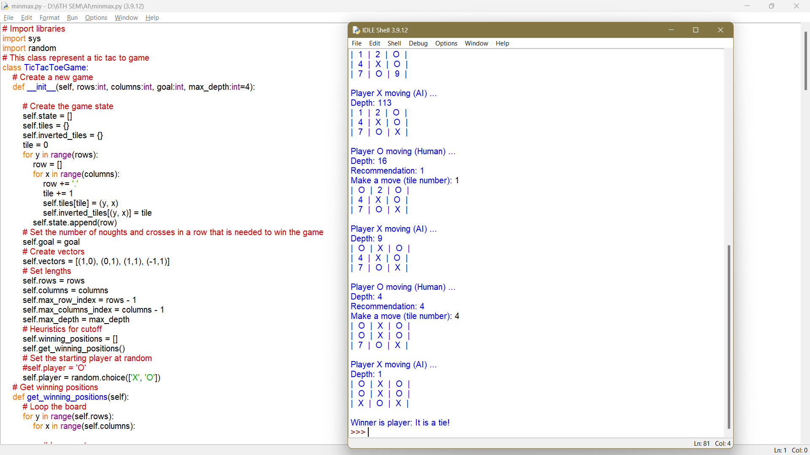

EX 7: UNIFICATION & RESOLUTION
AIM:
To Implement Unification and resolution in Python.
ALGORITHM:
1. If Ψ1 or Ψ2 is a variable or constant, then:
i. If Ψ1 or Ψ2 are identical, then return NULL.
ii. Else if Ψ1 is a variable:
1. Then if Ψ1 occurs in Ψ2, then return False
2. Else return (Ψ2 / Ψ1)
iii. Else if Ψ2 is a variable:
1. Then if Ψ2 occurs in Ψ1, then return False
2. Else return (Ψ1 / Ψ2)
iv. Else return False
2. If the initial Predicate symbol in Ψ1 and Ψ2 are not same, then returnFalse.
3. IF Ψ1 and Ψ2 have a different number of arguments, then return False.
4. Create Substitution list.
5. For i=1 to the number of elements in Ψ1.
i. Call Unify function with the ith element of Ψ1 and ith
element of Ψ2, and put the result into S.
ii. If S = False then returns False
iii. If S ≠ Null then append to Substitution list
6. Return Substitution list.
SOURCE CODE:
def get_index_comma(string):
"""Return index of commas in string"""
index_list = list()
# Count open parentheses
par_count = 0

for i in range(len(string)):
if string[i] == ',' and par_count == 0:
index_list.append(i)
elif string[i] == '(':
par_count += 1
elif string[i] == ')':
par_count -= 1
return index_list

def is_variable(expr):
"""Check if expression is variable """
for i in expr:
if i == '(':
return False
return True

def process_expression(expr):
""" input: - expression: 'Q(a, g(x, b), f(y))' return: - predicate symbol: Q - list of arguments ['a', 'g(x, b)', 'f(y)'] """
# Remove space in expression
expr = expr.replace(' ', '')
# Find the first index == '('
index = None
for i in range(len(expr)):
if expr[i] == '(':
index = i
break

# Return predicate symbol and remove predicate symbol in expression
predicate_symbol = expr[:index]
expr = expr.replace(predicate_symbol, '')

# Remove '(' in the first index and ')' in the last index
expr = expr[1:len(expr) - 1]

# List of arguments
arg_list = list()

# Split string with commas, return list of arguments
indices = get_index_comma(expr)

if len(indices) == 0:
arg_list.append(expr)
else:
arg_list.append(expr[:indices[0]])
for i, j in zip(indices, indices[1:]):
arg_list.append(expr[i + 1:j])
arg_list.append(expr[indices[len(indices) - 1] + 1:])

return predicate_symbol, arg_list

def get_arg_list(expr):
""" input: expression: 'Q(a, g(x, b), f(y))' return: full list of arguments: ['a', 'x', 'b', y'] """

_, arg_list = process_expression(expr)

flag = True
while flag:
flag = False

for i in arg_list:
if not is_variable(i):
flag = True
_, tmp = process_expression(i)
for j in tmp:
if j not in arg_list:
arg_list.append(j)
arg_list.remove(i)

return arg_list

def check_occurs(var, expr):
""" Check if var occurs in expr """
arg_list = get_arg_list(expr)
if var in arg_list:
return True
return False

def unify(expr1, expr2):
""" Unification Algorithm
Step 1: If Ψ1 or Ψ2 is a variable or constant, then:
a, If Ψ1 or Ψ2 are identical, then return NULL.
b, Else if Ψ1 is a variable:
- then if Ψ1 occurs in Ψ2, then return False
- Else return (Ψ2 / Ψ1)
c, Else if Ψ2 is a variable:
- then if Ψ2 occurs in Ψ1, then return False
- Else return (Ψ1 / Ψ2)
d, Else return False
Step 2: If the initial Predicate symbol in Ψ1 and Ψ2 are not same, then return False.
Step 3: IF Ψ1 and Ψ2 have a different number of arguments, then return False.
Step 4: Create Substitution list.
Step 5: For i=1 to the number of elements in Ψ1.
a, Call Unify function with the ith element of Ψ1 and ith element of Ψ2, and put the result into S.
b, If S = False then returns False
c, If S ≠ Null then append to Substitution list
Step 6: Return Substitution list. """

# Step 1:
if is_variable(expr1) and is_variable(expr2):
if expr1 == expr2:
return 'Null'
else:
return False
elif is_variable(expr1) and not is_variable(expr2):
if check_occurs(expr1, expr2):
return False
else:
tmp = str(expr2) + '/' + str(expr1)
return tmp
elif not is_variable(expr1) and is_variable(expr2):
if check_occurs(expr2, expr1):
return False
else:
tmp = str(expr1) + '/' + str(expr2)
return tmp
else:
predicate_symbol_1, arg_list_1 = process_expression(expr1)
predicate_symbol_2, arg_list_2 = process_expression(expr2)
# Step 2
if predicate_symbol_1 != predicate_symbol_2:
return False
# Step 3
elif len(arg_list_1) != len(arg_list_2):
return False
else:
# Step 4: Create substitution list
sub_list = list()
# Step 5:
for i in range(len(arg_list_1)):
tmp = unify(arg_list_1[i], arg_list_2[i])
if not tmp:
return False
elif tmp == 'Null':
pass
else:
if type(tmp) == list:
for j in tmp:
sub_list.append(j)
else:
sub_list.append(tmp)
# Step 6
return sub_list

if __name__ == "__main__":
# Data 1
f1 = 'p(b(A), X, f(g(Z)))'
f2 = 'p(Z, f(Y), f(Y))'

# Data 2
# f1 = 'Q(a, g(x, a), f(y))'
# f2 = 'Q(a, g(f(b), a), x)'

# Data 3
# f1 = 'Q(a, g(x, a, d), f(y))'
# f2 = 'Q(a, g(f(b), a), x)'

result = unify(f1, f2)
if not result:
print('Unification failed!')
else:
print('Unification successfully!')
print(result)

OUTPUT:
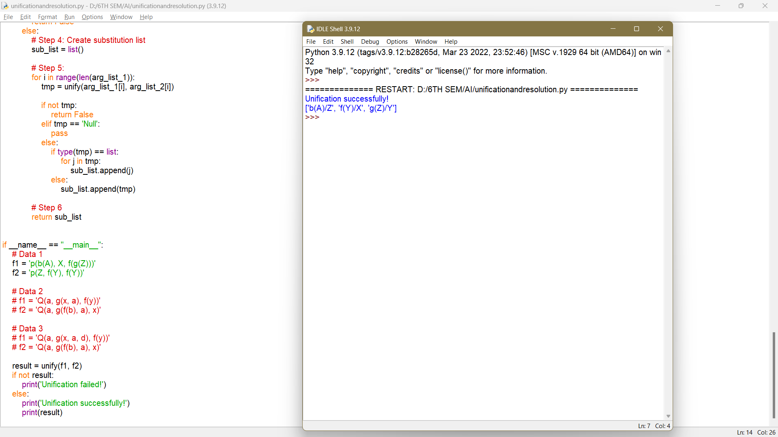

EX 8: IMPLEMENTATION OF KNOWLEDGE REPRESENTATION SCHEMES
AIM: Implementation of Knowledge Representation schemes
ALGORITHM:
1) Start
2) Get the input.
3) Check function to check if all cells are assigned or not. If there is any unassigned cell,
then this function will change the values of row and col accordingly.
4) Execute function to check if we can put a value in a particular cell or not.
5) If all cells are assigned then the sudoku is already solved. Else, pass by reference because
number_unassigned will change the values of row and col
6) Assign a solution for the sudoku. if we can't proceed with this solution then, reassign the
cell.
7) If a Solution is found, Print the Solved Sudoku. Else, print “No Solution”.
8) Stop.

SOURCE CODE:
#include <stdio.h>
#define SIZE 9
//sudoku problem
int matrix[9][9] = {
{5,3,0,0,7,0,0,0,0},
{6,0,0,1,9,5,0,0,0},
{0,9,8,0,0,0,0,6,0},
{8,0,0,0,6,0,0,0,3},
{4,0,0,8,0,3,0,0,1},
{7,0,0,0,2,0,0,0,6},
{0,6,0,0,0,0,2,8,0},
{0,0,0,4,1,9,0,0,5},
{0,0,0,0,8,0,0,7,9}
};
//function to print sudoku
void print_sudoku(){
int i,j;
for(i=0;i<SIZE;i++){
for(j=0;j<SIZE;j++){
printf("%d\t",matrix[i][j]);
}
printf("\n\n");
}
}
//function to check if all cells are assigned or not
//if there is any unassigned cell
//then this function will change the values of
//row and col accordingly
int number_unassigned(int *row, int *col){
int num_unassign = 0;
int i,j;
for(i=0;i<SIZE;i++){
for(j=0;j<SIZE;j++){
//cell is unassigned
if(matrix[i][j] == 0)
{
//changing the values of row and col
*row = i;
*col = j;
//there is one or more unassigned cells
num_unassign = 1;
return num_unassign;
}
}
}
return num_unassign;
}
//function to check if we can put a
//value in a paticular cell or not
int is_safe(int n, int r, int c)
{
int i,j;
//checking in row
for(i=0;i<SIZE;i++)
{
//there is a cell with same value
if(matrix[r][i] == n)
return 0;
}
//checking column
for(i=0;i<SIZE;i++)
{
//there is a cell with the value equal to i
if(matrix[i][c] == n)
return 0;
}
//checking sub matrix
int row_start = (r/3)*3;
int col_start = (c/3)*3;
for(i=row_start;i<row_start+3;i++)
{
for(j=col_start;j<col_start+3;j++)
{
if(matrix[i][j]==n)
return 0;
}
}
return 1;
}
//function to solve sudoku
//using backtracking
int solve_sudoku()
{
int row;
int col;
//if all cells are assigned then the sudoku is already solved
//pass by reference because number_unassigned will change the values of row and col
if(number_unassigned(&row, &col) == 0)
return 1;
int n,i;
//number between 1 to 9
for(i=1;i<=SIZE;i++)
{
//if we can assign i to the cell or not
//the cell is matrix[row][col]
if(is_safe(i, row, col))
{
matrix[row][col] = i;
//backtracking
if(solve_sudoku())
return 1;
//if we can't proceed with this solution
//reassign the cell
matrix[row][col]=0;
}
}
return 0;
}
int main()
{
if (solve_sudoku())
print_sudoku();
else
printf("No solution\n");
return 0;
}

OUTPUT:
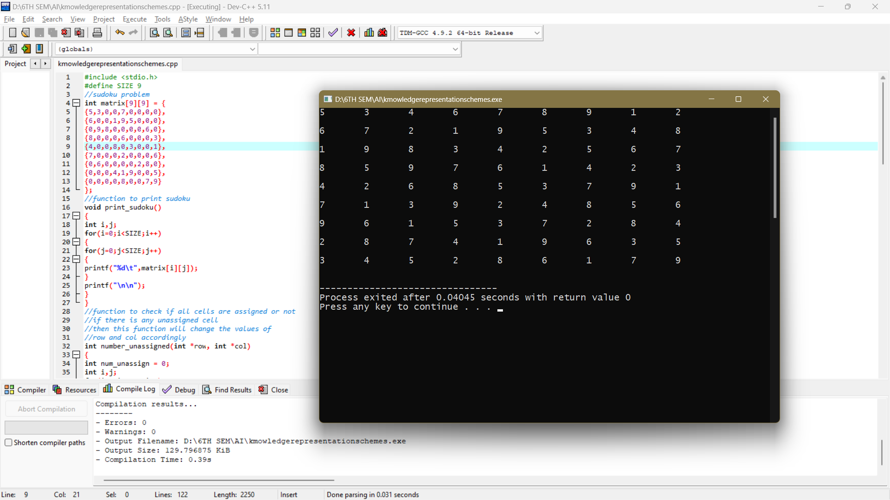

EX 9: UNCERTAIN METHODS FOR AN APPLICATION
AIM: To Implement Uncertain Methods for an application in Python.
ALGORITHM:
1. Start Program.
2. Import the required libraries.
3. Get the input for functions.
4. Train the program using the data.
5. Set X and Y axes on a graph.
6. Plot the points.
7. Print the Graph.
8. End Program.

SOURCE CODE:
import numpy as np
import matplotlib.pyplot as plt
x_func = np.linspace(-4,4,100)
y_func = x_func
x_train = np.random.uniform(-3, -2, 50)
y_train = x_train + np.random.randn(*x_train.shape)*0.5

x_train = np.concatenate([x_train, np.random.uniform(2, 3, 50)])
y_train = np.concatenate([y_train, x_train[50:] + np.random.randn(*x_train[50:].shape)*0.1])
x_test = np.linspace(-10,10,100)

fig, ax = plt.subplots(1,1,figsize=(10,5))
ax.scatter(x_train, y_train, label='training data')
ax.plot(x_func, y_func, ls='--', label='real function', color='green')
ax.set_xlabel('x')
ax.set_ylabel('y')
ax.legend()
ax.set_title('Data with uncertainty');

OUTPUT:
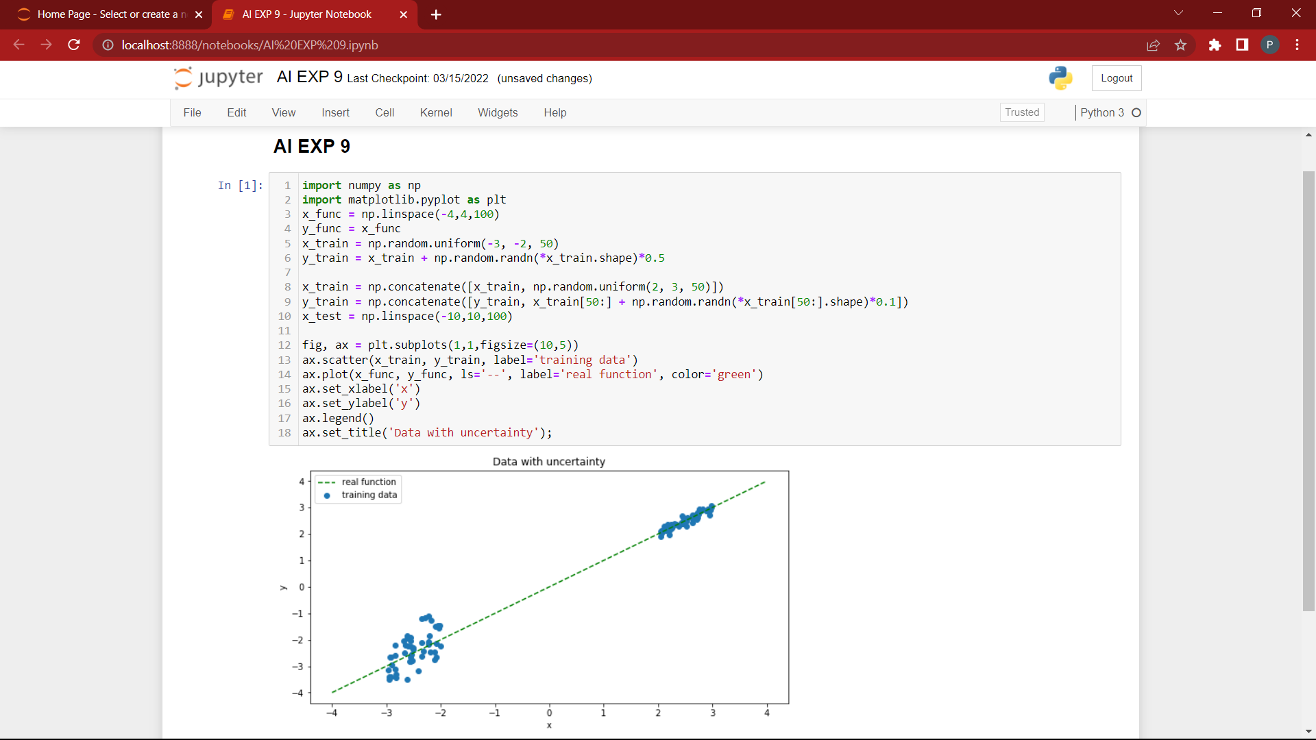

EX 10: Implementation of block world problem

AIM: Implement block world problems.
DESCRIPTION:
• Uninformed Search
• breadth (Breadth-First Search
• depth (Depth-First Search)
• Informed Search
• best (Best-First Search))
• a* (A-StarSearch)
ALGORITHM:
We create two lists – Open List and Closed List (A* Algorithm)
1. Initialize the open list
2. Initialize the closed list put the starting node on the open list (you can leave its f at zero)
3. while the open list is not empty
a. find the node with the least f on the open list, call it "q"
b. pop q off the open list
c. generate q's 8 successors and set their parents to q
d. for each successor
i. if successor is the goal, stop search
successor.g = q.g + distance between successor and q
successor.h = distance from goal to successor
successor.f = successor.g + successor.
ii. if a node with the same position as successor is in the OPEN list which
has a lower f than successor, skip this successor
iii. if a node with the same position as successor is in the CLOSED list which
has a lower f than successor, skip this successor otherwise, add the node
to the open list end (for loop)
e. push q on the closed list end (while loop)

SOURCE CODE:
class PREDICATE:
def __str__(self):
pass
def __repr__(self):
pass
def __eq__(self, other) :
pass
def __hash__(self):
pass
def get_action(self, world_state):
pass

class Operation:
def __str__(self):
pass
def __repr__(self):
pass
def __eq__(self, other) :
pass
def precondition(self):
pass
def delete(self):
pass
def add(self):
pass

class ON(PREDICATE):
def __init__(self, X, Y):
self.X = X
self.Y = Y
def __str__(self):
return "ON({X},{Y})".format(X=self.X,Y=self.Y)
def __repr__(self):
return self.__str__()
def __eq__(self, other) :
return self.__dict__ == other.__dict__ and self.__class__ == other.__class__
def __hash__(self):
return hash(str(self))
def get_action(self, world_state):
return StackOp(self.X,self.Y)

class ONTABLE(PREDICATE):
def __init__(self, X):
self.X = X
def __str__(self):
return "ONTABLE({X})".format(X=self.X)
def __repr__(self):
return self.__str__()
def __eq__(self, other) :
return self.__dict__ == other.__dict__ and self.__class__ == other.__class__
def __hash__(self):
return hash(str(self))
def get_action(self, world_state):
return PutdownOp(self.X)

class CLEAR(PREDICATE):
def __init__(self, X):
self.X = X
def __str__(self):
return "CLEAR({X})".format(X=self.X)
self.X = X
def __repr__(self):
return self.__str__()
def __eq__(self, other) :
return self.__dict__ == other.__dict__ and self.__class__ == other.__class__
def __hash__(self):
return hash(str(self))
def get_action(self, world_state):
for predicate in world_state:
if isinstance(predicate,ON) and predicate.Y==self.X:
return UnstackOp(predicate.X, predicate.Y)
return None

class HOLDING(PREDICATE):
def __init__(self, X):
self.X = X
def __str__(self):
return "HOLDING({X})".format(X=self.X)
def __repr__(self):
return self.__str__()
def __eq__(self, other) :
return self.__dict__ == other.__dict__ and self.__class__ == other.__class__
def __hash__(self):
return hash(str(self))
def get_action(self, world_state):
X = self.X
if ONTABLE(X) in world_state:
return PickupOp(X)
else:
for predicate in world_state:
if isinstance(predicate,ON) and predicate.X==X:
return UnstackOp(X,predicate.Y)

class ARMEMPTY(PREDICATE):
def __init__(self):
pass
def __str__(self):
return "ARMEMPTY"
def __repr__(self):
return self.__str__()
def __eq__(self, other) :
return self.__dict__ == other.__dict__ and self.__class__ == other.__class__
def __hash__(self):
return hash(str(self))
def get_action(self, world_state=[]):
for predicate in world_state:
if isinstance(predicate,HOLDING):
return PutdownOp(predicate.X)
return None

class StackOp(Operation):
def __init__(self, X, Y):
self.X = X
self.Y = Y
def __str__(self):
return "STACK({X},{Y})".format(X=self.X,Y=self.Y)
def __repr__(self):
return self.__str__()
def __eq__(self, other) :
return self.__dict__ == other.__dict__ and self.__class__ == other.__class__
def precondition(self):
return [ CLEAR(self.Y) , HOLDING(self.X) ]
def delete(self):
return [ CLEAR(self.Y) , HOLDING(self.X) ]
def add(self):
return [ ARMEMPTY() , ON(self.X,self.Y) ]

class UnstackOp(Operation):
def __init__(self, X, Y):
self.X = X
self.Y = Y
def __str__(self):
return "UNSTACK({X},{Y})".format(X=self.X,Y=self.Y)
def __repr__(self):
return self.__str__()
def __eq__(self, other) :
return self.__dict__ == other.__dict__ and self.__class__ == other.__class__
def precondition(self):
return [ ARMEMPTY() , ON(self.X,self.Y) , CLEAR(self.X) ]
def delete(self):
return [ ARMEMPTY() , ON(self.X,self.Y) ]
def add(self):
return [ CLEAR(self.Y) , HOLDING(self.X) ]

class PickupOp(Operation):
def __init__(self, X):
self.X = X
def __str__(self):
return "PICKUP({X})".format(X=self.X)
def __repr__(self):
return self.__str__()
def __eq__(self, other) :
return self.__dict__ == other.__dict__ and self.__class__ == other.__class__
def precondition(self):
return [ CLEAR(self.X) , ONTABLE(self.X) , ARMEMPTY() ]
def delete(self):
return [ ARMEMPTY() , ONTABLE(self.X) ]
def add(self):
return [ HOLDING(self.X) ]

class PutdownOp(Operation):
def __init__(self, X):
self.X = X
def __str__(self):
return "PUTDOWN({X})".format(X=self.X)
def __repr__(self):
return self.__str__()
def __eq__(self, other) :
return self.__dict__ == other.__dict__ and self.__class__ == other.__class__
def precondition(self):
return [ HOLDING(self.X) ]
def delete(self):
return [ HOLDING(self.X) ]
def add(self):
return [ ARMEMPTY() , ONTABLE(self.X) ]

def isPredicate(obj):
predicates = [ON, ONTABLE, CLEAR, HOLDING, ARMEMPTY]
for predicate in predicates:
if isinstance(obj,predicate):
return True
return False

def isOperation(obj):
operations = [StackOp, UnstackOp, PickupOp, PutdownOp]
for operation in operations:
if isinstance(obj,operation):
return True
return False

def arm_status(world_state):
for predicate in world_state:
if isinstance(predicate, HOLDING):
return predicate
return ARMEMPTY()

class GoalStackPlanner:
def __init__(self, initial_state, goal_state):
self.initial_state = initial_state
self.goal_state = goal_state

def get_steps(self):
steps = []
stack = []
#World State/Knowledge Base
world_state = self.initial_state.copy()
#Initially push the goal_state as compound goal onto the stack
stack.append(self.goal_state.copy())
#Repeat until the stack is empty
while len(stack)!=0:
#Get the top of the stack
stack_top = stack[-1]
#If Stack Top is Compound Goal, push its unsatisfied goals onto stack
if type(stack_top) is list:
compound_goal = stack.pop()
for goal in compound_goal:
if goal not in world_state:
stack.append(goal)

elif isOperation(stack_top):
operation = stack[-1]
all_preconditions_satisfied = True
for predicate in operation.delete():
if predicate not in world_state:
all_preconditions_satisfied = False
stack.append(predicate)
if all_preconditions_satisfied:
stack.pop()
steps.append(operation)

for predicate in operation.delete():
world_state.remove(predicate)
for predicate in operation.add():
world_state.append(predicate)
elif stack_top in world_state:
stack.pop()
else:
unsatisfied_goal = stack.pop()
action = unsatisfied_goal.get_action(world_state)
stack.append(action)
for predicate in action.precondition():
if predicate not in world_state:
stack.append(predicate)
return steps

if __name__ == '__main__':
initial_state = [
ON('B','A'),ON('E', 'B'),
ONTABLE('A'),ONTABLE('C'),ONTABLE('D'),
CLEAR('B'),CLEAR('C'),CLEAR('D'),CLEAR('E'),
ARMEMPTY()
]
goal_state = [
ON('B','D'),ON('D','C'), ON('C', 'A'),ON('A', 'E'),
ONTABLE('A'),
CLEAR('B'),CLEAR('C'), CLEAR('D'),CLEAR('E'),
ARMEMPTY()
]
goal_stack = GoalStackPlanner(initial_state=initial_state, goal_state=goal_state)
steps = goal_stack.get_steps()
print("UNSTACK(E,B)")
print("PUTDOWN(E)")
for i in steps:
print(i)

OUTPUT:
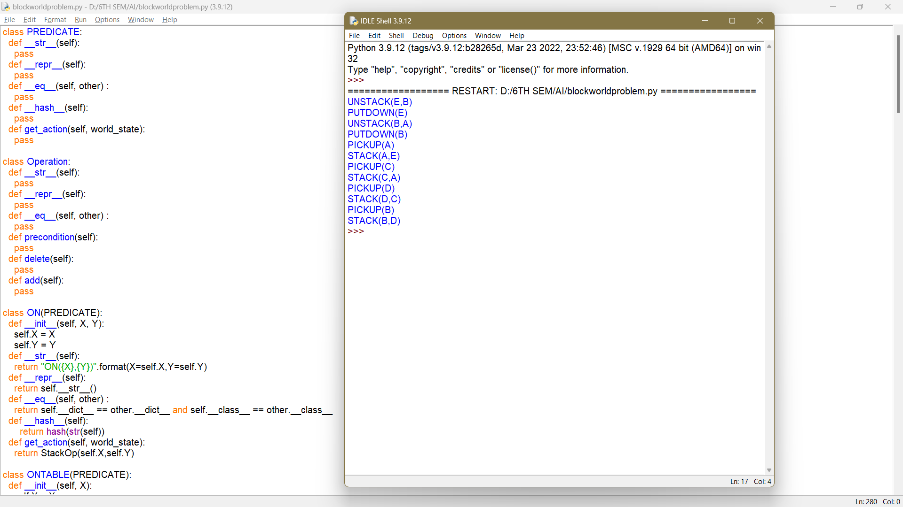

EX 11: Implementation of learning algorithms for an application
AIM: Implementation of learning algorithms for an application
DESCRIPTION
Here, we implement a Decision Tree to determine if a product has enough weight and is pushed
to the right (R) or is of insufficient weight and is pushed to the left (L). The Dataset used is the
Balance Scale Weight & Distance Database.
ALGORITHM:
Entropy is the measure of uncertainty of a random variable, it characterizes the impurity of an
arbitrary collection of examples. The higher the entropy the more the information content.
1. Start
2. Consider the whole training set as the root
3. Attributes are assumed to be categorical and are distributed recursively according to
values using statistical methods
4. Find the best attribute and place it on the root node of the tree.
5. Now, split the training set of the dataset into subsets. While making the subset make
sure that each subset of the training dataset has the same value for an attribute. The
entropy increases for each partition
6. Find leaf nodes in all branches by repeating steps 1 and 2 on each subset
7. End

SOURCE CODE:
import numpy as np
import matplotlib.pyplot as plt

import pandas as pd
import seaborn as sns

%matplotlib inline

from sklearn.datasets import load_boston
boston_dataset = load_boston()

boston = pd.DataFrame(boston_dataset.data,columns=boston_dataset.feature_names)
boston.head()

boston['MEDV'] = boston_dataset.target
boston.isnull().sum()
sns.set(rc={'figure.figsize':(11.7,8.27)})
sns.distplot(boston['MEDV'], bins=30)
plt.show()

correlation_matrix = boston.corr().round(2)
# annot = True to print the values inside the square
sns.heatmap(data=correlation_matrix, annot=True)

plt.figure(figsize=(20, 5))

features = ['LSTAT', 'RM']
target = boston['MEDV']

for i, col in enumerate(features):
plt.subplot(1, len(features) , i+1)
x = boston[col]
y = target
plt.scatter(x, y, marker='o')
plt.title(col)
plt.xlabel(col)
plt.ylabel('MEDV')

OUTPUT:
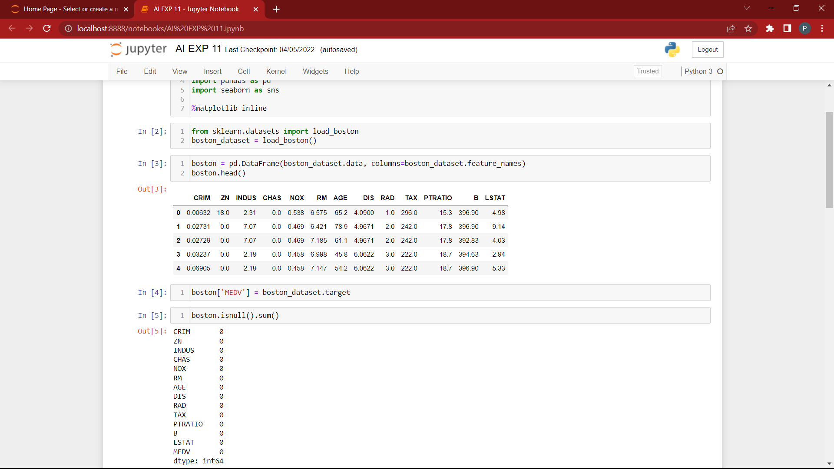
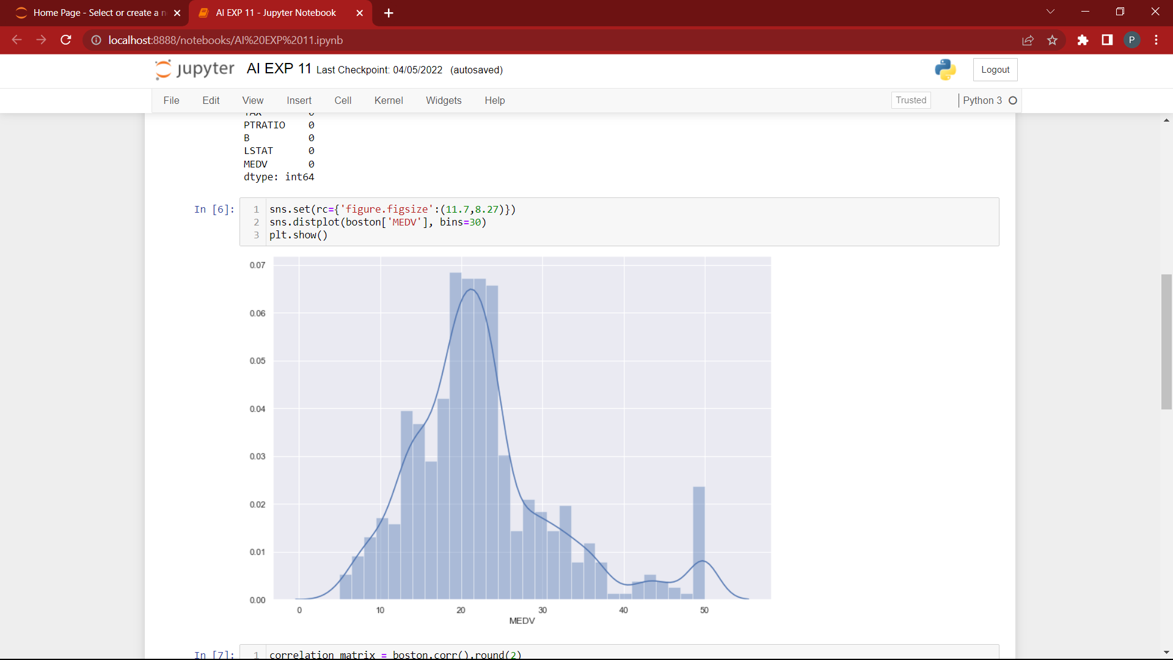
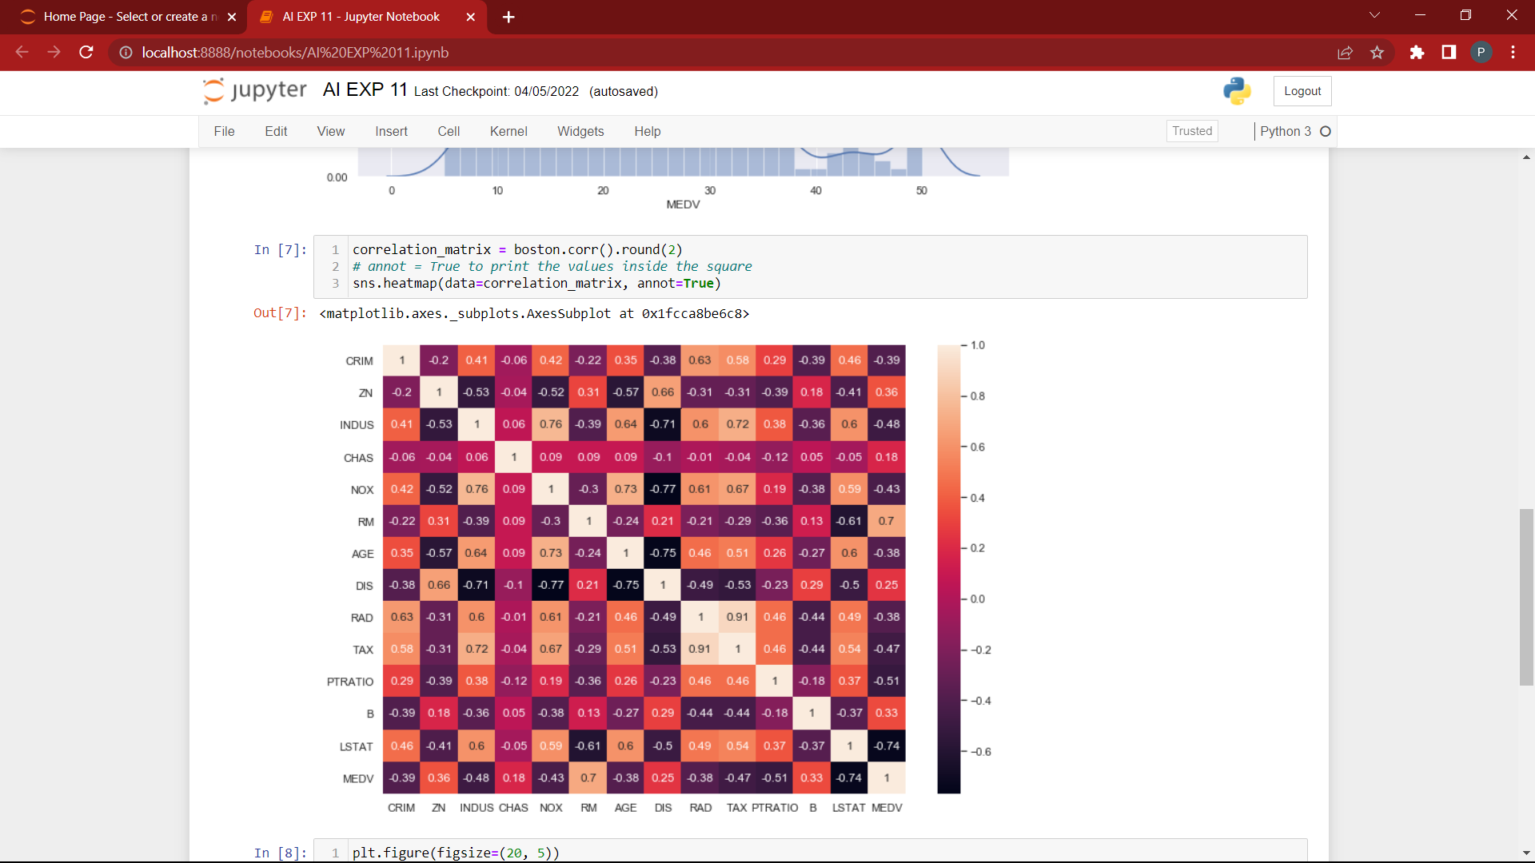

EX 12: Implementation of Development of ensemble model for an application
Aim:
Implementation of Development of ensemble model for an application
DESCRIPTION:
Ensembles can give you a boost in accuracy on your dataset. In this post you will discover
how you can create some of the most powerful types of ensembles in Python using scikit-
learn. This case study will step you through Boosting, Bagging and Majority Voting and show
you how you can continue to ratchet up the accuracy of the models on your own datasets.

Algorithm:
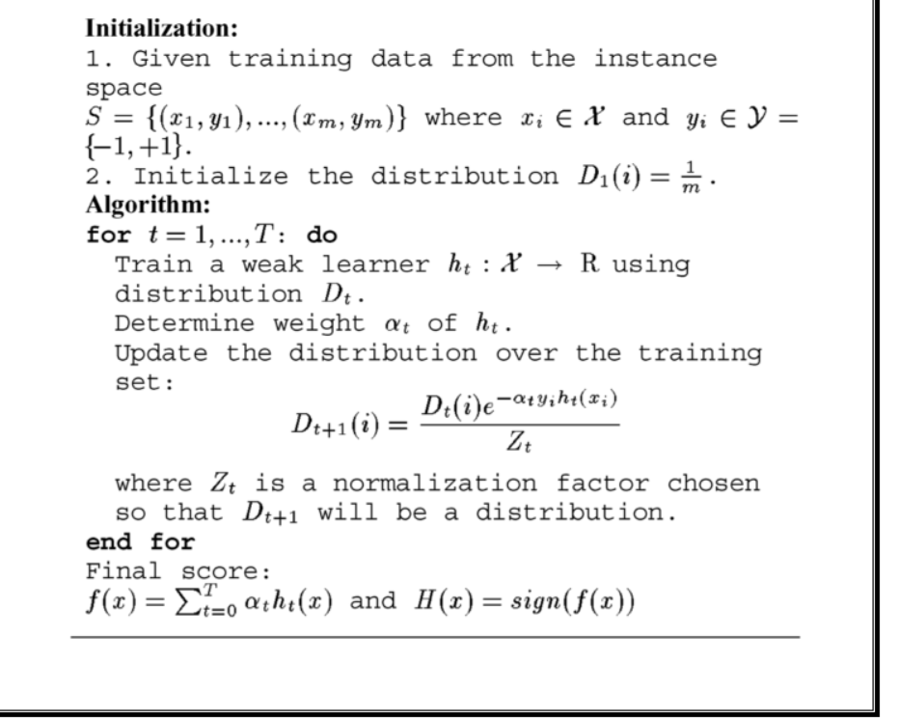

SOURCE CODE:
# Load libraries
from sklearn.ensemble import AdaBoostClassifier
from sklearn import datasets
# Import train_test_split function
from sklearn.model_selection import train_test_split
#Import scikit-learn metrics module for accuracy calculation
from sklearn import metrics

# Load data
iris = datasets.load_iris()
X = iris.data
y = iris.target

# Split dataset into training set and test set
X_train, X_test, y_train, y_test = train_test_split(X, y, test_size=0.3) # 70% training and 30% test

# Create adaboost classifer object
abc = AdaBoostClassifier(n_estimators=50,learning_rate=1)
# Train Adaboost Classifer
model = abc.fit(X_train, y_train)
#Predict the response for test dataset
y_pred = model.predict(X_test)

# Model Accuracy, how often is the classifier correct?
print("Accuracy:",metrics.accuracy_score(y_test, y_pred))

# Load libraries
from sklearn.ensemble import AdaBoostClassifier
# Import Support Vector Classifier
from sklearn.svm import SVC
#Import scikit-learn metrics module for accuracy calculation
from sklearn import metrics
svc=SVC(probability=True, kernel='linear')
# Create adaboost classifer object
abc =AdaBoostClassifier(n_estimators=50, base_estimator=svc,learning_rate=1)
# Train Adaboost Classifer
model = abc.fit(X_train, y_train)
#Predict the response for test dataset
y_pred = model.predict(X_test)
# Model Accuracy, how often is the classifier correct?
print("Accuracy:",metrics.accuracy_score(y_test, y_pred))

OUTPUT:
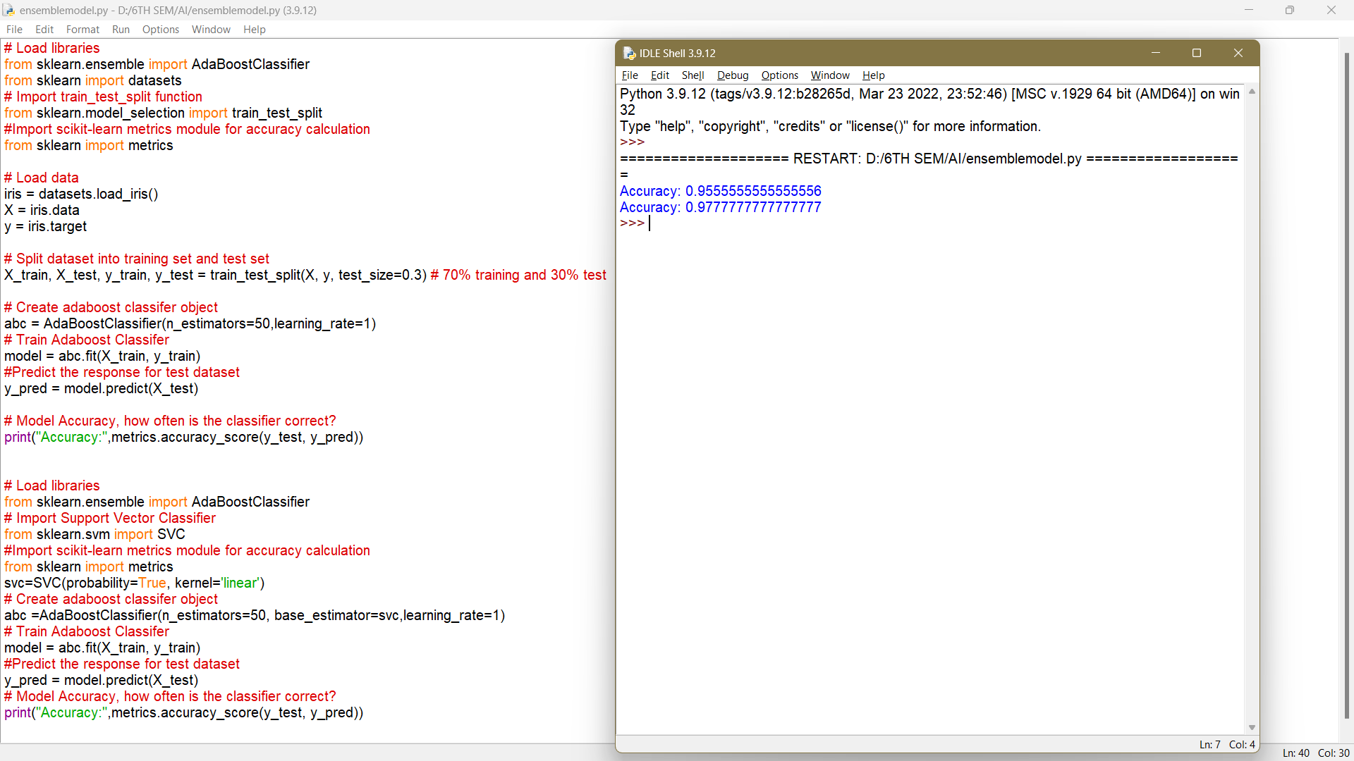

Exp no 13: Natural language processing-Levels of NLP - Text Preprocessing

# import the necessary libraries
import nltk
import string
import re
1. Text Lowercase:
def text_lowercase(text):
return text.lower()
input_str = "Hey, did you know that the summer break is coming? Amazing right !! It's only 5
more days !!"
text_lowercase (input_str)
OUTPUT:
Input: “Hey, did you know that the summer break is coming? Amazing right!! It’s only 5 more
days!!”
Output: “hey, did you know that the summer break is coming? amazing right!! it’s only 5 more
days!!”
2. Remove numbers:
# Remove numbers
def remove_numbers(text):
result = re.sub(r'\d+', '', text)
return result
input_str = "There are 3 balls in this bag, and 12 in the other one."
remove_numbers(input_str)
Input: “There are 3 balls in this bag, and 12 in the other one.”
Output: ‘There are balls in this bag, and in the other one.’
3. Convert numbers into words
# import the inflect library
import inflect
p = inflect.engine()
# convert number into words
def convert_number(text):
# split string into list of words
temp_str = text.split()
# initialise empty list
new_string = []
for word in temp_str:
# if word is a digit, convert the digit
# to numbers and append into the new_string list
if word.isdigit():
temp = p.number_to_words(word)
new_string.append(temp)
# append the word as it is
else:
new_string.append(word)
# join the words of new_string to form a string
temp_str = ' '.join(new_string)
return temp_str
input_str = 'There are 3 balls in this bag, and 12 in the other one.'
convert_number(input_str)
Input: “There are 3 balls in this bag, and 12 in the other one.”
Output: “There are three balls in this bag, and twelve in the other one.”
4. Remove punctuation:
# remove punctuation
def remove_punctuation(text):
translator = str.maketrans('', '', string.punctuation)
return text.translate(translator)
input_str = "Hey, did you know that the summer break is coming? Amazing right !!
It's only 5 more days !!"
remove_punctuation(input_str)
Input: “Hey, did you know that the summer break is coming? Amazing right!! It’s
only 5 more days!!”
Output: “Hey did you know that the summer break is coming Amazing right Its only
5 more days”
5. Remove whitespaces:
# remove whitespace from text
def remove_whitespace(text):
return " ".join(text.split())
input_str = " we don't need the given questions"
remove_whitespace(input_str)
Input: " we don't need the given questions"
Output: "we don't need the given questions"
6. Remove default stopwords:
from nltk.corpus import stopwords
from nltk.tokenize import word_tokenize
# remove stopwords function
def remove_stopwords(text):
stop_words = set(stopwords.words("english"))
word_tokens = word_tokenize(text)
filtered_text = [word for word in word_tokens if word not in stop_words]
return filtered_text
example_text = "This is a sample sentence and we are going to remove the stopwords
from this."
remove_stopwords(example_text)
The NLTK library has a set of stopwords and we can use these to remove
stopwords from our text and return a list of word tokens.
Input: “This is a sample sentence and we are going to remove the stopwords from
this”
Output: [‘This’, ‘sample’, ‘sentence’, ‘going’, ‘remove’, ‘stopwords’]
7. Stemming:
Stemming is the process of getting the root form of a word. Stem or root is the part to
which inflectional affixes (-ed, -ize, -de, -s, etc.) are added. The stem of a word is
created by removing the prefix or suffix of a word. So, stemming a word may not
result in actual words.
Example:
books ---> book
looked ---> look
denied ---> deni
flies ---> fli
from nltk.stem.porter import PorterStemmer
from nltk.tokenize import word_tokenize
stemmer = PorterStemmer()
# stem words in the list of tokenized words
def stem_words(text):
word_tokens = word_tokenize(text)
stems = [stemmer.stem(word) for word in word_tokens]
return stems
text = 'data science uses scientific methods algorithms and many types of processes'
stem_words(text)
Input: ‘data science uses scientific methods algorithms and many types of processes’
Output: [‘data’, ‘scienc’, ‘use’, ‘scientif’, ‘method’, ‘algorithm’, ‘and’, ‘mani’,
‘type’, ‘of’, ‘process’]
8. Lemmatization:
Lemmatization also converts a word to its root form. The only difference is that
lemmatization ensures that the root word belongs to the language.
from nltk.stem import WordNetLemmatizer
from nltk.tokenize import word_tokenize
lemmatizer = WordNetLemmatizer()
# lemmatize string
def lemmatize_word(text):
word_tokens = word_tokenize(text)
# provide context i.e. part-of-speech
lemmas = [lemmatizer.lemmatize(word, pos ='v') for word in word_tokens]
return lemmas
text = 'data science uses scientific methods algorithms and many types of processes'
lemmatize_word(text)
Input: ‘data science uses scientific methods algorithms and many types of processes’
Output: [‘data’, ‘science’, ‘use’, ‘scientific’, ‘methods’, ‘algorithms’, ‘and’, ‘many’,
‘type’, ‘of’, ‘process’]

EX 14: NLP PROGRAMS
AIM:
To implement NLP programs using python.
ALGORITHM:
Text Preprocessing
Since, text is the most unstructured form of all the available data, various types of noise are present
in it and the data is not readily analyzable without any pre-processing. The entire process of cleaning
and standardization of text, making it noise-free and ready for analysis is known as text reprocessing.
It is predominantly comprised of three steps:
1. Noise Removal
2. Lexicon Normalization
3. Object Standardization
Noise Removal

Any piece of text which is not relevant to the context of the data and the end-
output can be specified as the noise.

For example – language stop words (commonly used words of a language – is,
am, the, of, in etc.), URLs or links, social media entities (mentions, hashtags),
punctuations and industry specific words. This step deals with removal of all
types of noisy entities present in the text.
A general approach for noise removal is to prepare a dictionary of noisy entities,
and iterate the text object by tokens (or by words), eliminating those tokens
which are present in the noise dictionary.

SOURCE CODE:
import pandas as pd
import numpy as np
import string
import seaborn as sns
import matplotlib.pyplot as plt
from nltk.corpus import stopwords
from sklearn.feature_extraction.text import CountVectorizer
from sklearn.feature_extraction.text import TfidfTransformer
from sklearn.model_selection import train_test_split
from sklearn.svm import SVC
from collections import Counter
from sklearn.metrics import classification_report,confusion_matrix
from sklearn.model_selection import GridSearchCV
%matplotlib inline
# Load data
data = pd.read_excel('data.xlsx')
# Rename names columns
data.columns = ['label', 'messages']
data["length"] = data["messages"].apply(len)
data.sort_values(by='length', ascending=False).head(10)
data.hist(column = 'length', by ='label',figsize=(12,4), bins = 5)
def transform_message(message):
message_not_punc = [] # Message without punctuation
i = 0
for punctuation in message:
if punctuation not in string.punctuation:
message_not_punc.append(punctuation)
# Join words again to form the string.
message_not_punc = ''.join(message_not_punc)

# Remove any stopwords for message_not_punc, but first we should
# to transform this into the list.
message_clean = list(message_not_punc.split(" "))
while i <= len(message_clean):
for mess in message_clean:
if mess.lower() in stopwords.words('english'):
message_clean.remove(mess)
i =i +1
return message_clean
vectorization = CountVectorizer(analyzer = transform_message )
X = vectorization.fit(data['messages'])

X_transform = X.transform([data['messages']])

# TF-IDF
tfidf_transformer = TfidfTransformer().fit(X_transform)
X_tfidf = tfidf_transformer.transform(X_transform)
print(X_tfidf.shape)

# Classification Model
X_train, X_test, y_train, y_test = train_test_split(X_tfidf, data['messages'], test_size=0.30,random_state = 50)
clf = SVC(kernel='linear').fit(X_train, y_train)
# Test model

predictions = clf.predict(X_test)
print('predicted', predictions)
# Is our model reliable?
print (classification_report(y_test, predictions))
print(confusion_matrix(y_test,predictions))
OUTPUT:

EX 15: Deep Learning method for Automatic Handwriting Recognition
AIM:
To Create a Program to apply Deep Learning method for Automatic
Handwriting Recognition in Python
ALGORITHM:
1. Start Program.
2. Load the data.
3. Train the program.
4. Select random data from the csv.
5. Predict which letter the selected data is.
6. Check the accuracy.
7. Print the result.
8. End Program.

SOURCE CODE:
import argparse
import json

import cv2
import editdistance
from path import Path

from DataLoaderIAM import DataLoaderIAM, Batch
from Model import Model, DecoderType
from SamplePreprocessor import preprocess

class FilePaths:
"filenames and paths to data"
fnCharList = '../model/charList.txt'
fnSummary = '../model/summary.json'
fnInfer = '../data/test.png'
fnCorpus = '../data/corpus.txt'

def write_summary(charErrorRates, wordAccuracies):
with open(FilePaths.fnSummary, 'w') as f:
json.dump({'charErrorRates': charErrorRates, 'wordAccuracies': wordAccuracies}, f)

def train(model, loader):
"train NN"
epoch = 0 # number of training epochs since start
summaryCharErrorRates = []
summaryWordAccuracies = []
bestCharErrorRate = float('inf') # best valdiation character error rate
noImprovementSince = 0 # number of epochs no improvement of character error rate occured
earlyStopping = 25 # stop training after this number of epochs without improvement
while True:
epoch += 1
print('Epoch:', epoch)

# train
print('Train NN')
loader.trainSet()
while loader.hasNext():
iterInfo = loader.getIteratorInfo()
batch = loader.getNext()
loss = model.trainBatch(batch)
print(f'Epoch: {epoch} Batch: {iterInfo[0]}/{iterInfo[1]} Loss: {loss}')
# validate
charErrorRate, wordAccuracy = validate(model, loader)

# write summary
summaryCharErrorRates.append(charErrorRate)
summaryWordAccuracies.append(wordAccuracy)
write_summary(summaryCharErrorRates, summaryWordAccuracies)

# if best validation accuracy so far, save model parameters
if charErrorRate < bestCharErrorRate:
print('Character error rate improved, save model')
bestCharErrorRate = charErrorRate
noImprovementSince = 0
model.save()
else:
print(f'Character error rate not improved, best so far: {charErrorRate * 100.0}%')
noImprovementSince += 1

# stop training if no more improvement in the last x epochs
if noImprovementSince >= earlyStopping:
print(f'No more improvement since {earlyStopping} epochs. Training stopped.')
break

def validate(model, loader):
"validate NN"
print('Validate NN')
loader.validationSet()
numCharErr = 0
numCharTotal = 0
numWordOK = 0
numWordTotal = 0
while loader.hasNext():
iterInfo = loader.getIteratorInfo()
print(f'Batch: {iterInfo[0]} / {iterInfo[1]}')
batch = loader.getNext()
(recognized, _) = model.inferBatch(batch)

print('Ground truth -> Recognized')
for i in range(len(recognized)):
numWordOK += 1 if batch.gtTexts[i] == recognized[i] else 0
numWordTotal += 1
dist = editdistance.eval(recognized[i], batch.gtTexts[i])
numCharErr += dist
numCharTotal += len(batch.gtTexts[i])
print('[OK]' if dist == 0 else '[ERR:%d]' % dist, '"' + batch.gtTexts[i] + '"', '->',
'"' + recognized[i] + '"')

# print validation result
charErrorRate = numCharErr / numCharTotal
wordAccuracy = numWordOK / numWordTotal
print(f'Character error rate: {charErrorRate * 100.0}%. Word accuracy: {wordAccuracy * 100.0}%.')
return charErrorRate, wordAccuracy

def infer(model, fnImg):
"recognize text in image provided by file path"
img = preprocess(cv2.imread(fnImg, cv2.IMREAD_GRAYSCALE), Model.imgSize)
batch = Batch(None, [img])
(recognized, probability) = model.inferBatch(batch, True)
print(f'Recognized: "{recognized[0]}"')
print(f'Probability: {probability[0]}')

def main():
"main function"
parser = argparse.ArgumentParser()
parser.add_argument('--train', help='train the NN', action='store_true')
parser.add_argument('--validate', help='validate the NN', action='store_true')
parser.add_argument('--decoder', choices=['bestpath', 'beamsearch', 'wordbeamsearch'],
default='bestpath',help='CTC decoder')
parser.add_argument('--batch_size', help='batch size', type=int, default=100)
parser.add_argument('--data_dir', help='directory containing IAM dataset', type=Path, required=False)
parser.add_argument('--fast', help='use lmdb to load images', action='store_true')
parser.add_argument('--dump', help='dump output of NN to CSV file(s)', action='store_true')
args = parser.parse_args()

# set chosen CTC decoder
if args.decoder == 'bestpath':
decoderType = DecoderType.BestPath
elif args.decoder == 'beamsearch':
decoderType = DecoderType.BeamSearch
elif args.decoder == 'wordbeamsearch':
decoderType = DecoderType.WordBeamSearch

# train or validate on IAM dataset
if args.train or args.validate:
# load training data, create TF model
loader = DataLoaderIAM(args.data_dir, args.batch_size, Model.imgSize, Model.maxTextLen, args.fast)

# save characters of model for inference mode
open(FilePaths.fnCharList, 'w').write(str().join(loader.charList))

# save words contained in dataset into file
open(FilePaths.fnCorpus, 'w').write(str(' ').join(loader.trainWords + loader.validationWords))

# execute training or validation
if args.train:
model = Model(loader.charList, decoderType)
train(model, loader)
elif args.validate:
model = Model(loader.charList, decoderType, mustRestore=True)
validate(model, loader)
# infer text on test image
else:
model = Model(open(FilePaths.fnCharList).read(), decoderType, mustRestore=True, dump=args.dump)
infer(model, FilePaths.fnInfer)

if __name__ == '__main__':
main()

OUTPUT:

